DATEROEM WOOD SALES
System Documentation
Backend Server
The Java service that holds every business rule
Document | Backend Server
Document number | DWS-BE-01
Version | 1.1
Date | 24 October 2026
Intended readers | Developers and maintainers of the system
Classification | Internal - contains system design details; share only with authorised staff
Describes the Spring Boot backend: how it is organised, every feature module with its files and database tables, security, scheduled jobs, configuration, and the full list of its 196 endpoints.

Document control
Version | Date | Change
1.0 | 3 October 2026 | First complete edition, written from the source code as it stood on this date.
1.1 | 3 October 2026 | Added one approved phone per account (admin approval of new phones) and the fingerprint app lock.
1.1 | 4 October 2026 | Sign-in by username or email; checked emails and chosen usernames at sign-up (website and Google); replacing a campaign's products in one request; campaign media kept on edit; Google client id set.
1.1 | 5 October 2026 | Approved computers for the desktop app (DesktopClientFilter, ComputerService, migration 031): the acting user on desktop calls now comes from the sign-in; 12-hour desktop sign-ins; one SuperAdmin, who alone approves phones and computers and can correct usernames; secret columns hidden in the database browser.
1.1 | 7 October 2026 | Help page questions (FAQs): FaqController and FaqService, six endpoints.
1.1 | 8 October 2026 | M-Pesa callbacks also at /api/dateroem-payments (the production address); paybill or till as settings (app.mpesa.transaction-type, app.mpesa.party-b); running on a hosted server (DWS-CFG-03).
1.1 | 9 October 2026 | Retiring a product (retire, bring back, needs-attention list, three endpoints); security review: payment results confirmed with Safaricom, order quantity checks, staff-only phone sign-in, payout amount and recipient checks, failed-payment clean-up.
1.1 | 9 October 2026 | Bulk order pictures for the website (ShowcaseController and ShowcaseService, five endpoints, Marketer or admin enforced).
1.1 | 17 October 2026 | M-Pesa settings live since 16 October 2026 (Appendix settings table).
1.1 | 17 October 2026 | Website payments list with M-Pesa receipts (GET /api/orders/payments, admin); receipts stored in PRODUCT_PAYMENTS.Mpesa_Receipt.
1.1 | 17 October 2026 | Phone numbers confirmed by an SMS code: PhoneVerificationService, SmsSender, four /api/auth phone endpoints, Africa's Talking (Airtel numbers for now); an unconfirmed customer's first order waits for it; the admin user list shows when a number was confirmed.
1.1 | 18 October 2026 | Sign-in tokens issued before the clean-up of 18 October 2026 are refused (app.auth.tokens-valid-from); error answers carry no stack traces (server.error.*).
1.1 | 20 October 2026 | Colour theme per account: USERS.Theme (migration 037), returned at sign-in and by /api/auth/me, saved with PUT /api/auth/me/theme.
1.1 | 23 October 2026 | Order tickets (OrderTickets, migration 038), Track my order (GET /api/orders/track, open, with limits on wrong tries) and Share driver (PATCH /api/deliveries/light/{id}/share-driver); the endpoint list now also shows PUT /api/auth/me/theme.
1.1 | 24 October 2026 | Profiles, passwords and the idle lock (migration 039): ProfileService, AccountSecurity (per-account sign-in cut-off), PasswordChangeFilter, AppSettings and SettingsController; seven new endpoints.
1.1 | 24 October 2026 | Home overview (GET /api/insights/overview), the company card on the server (GET and PUT /api/settings/company) and deadline flags on waiting orders (DeliveryDeadline).
1.1 | 24 October 2026 | Worker details and documents (migration 040): WorkerService, WorkerController (/api/workers, 14 endpoints) and DataCipher, which encrypts ID-type numbers and document photos with app.workers.data-secret.
Keep this document up to date: when a feature, setting or server changes, edit the matching section here and add a line to the table above.
Contents
1 Introduction 5
1.1 Purpose of this document 5
1.2 Related documents 5
2 Overview 6
2.1 Role in the system 6
2.2 Technology 7
2.3 Design conventions 7
3 Source code layout 8
4 Security model 9
4.1 Accounts and roles 9
4.2 Sign-in tokens 9
4.3 Approved phones (mobile app) 10
4.4 Approved computers (desktop app) 12
4.5 One SuperAdmin 12
4.6 How a caller is identified 13
4.7 What is public 13
5 Feature modules 15
5.1 Accounts, sign-in and users 15
5.2 Products 17
5.3 Marketing campaigns 18
5.4 Orders and checkout 18
5.5 Deliveries 19
5.6 Trips 20
5.7 Trees, farmers and farmer payments 23
5.8 Expenses 23
5.9 Loans and capital 23
5.10 Transactions and payments 23
5.11 SMS queue (offline M-Pesa payments) 24
5.12 Help page questions (FAQs) 26
5.13 Bulk order pictures (showcase) 26
5.14 Ratings and reviews 26
5.15 Delivery areas, machines and vehicles 27
5.16 Insights, AI and data browser 27
6 Scheduled jobs 28
7 External services and network resilience 29
8 Error answers 30
9 Configuration 31
10 Building and running 34
11 Known limitations and future work 35
12 Development history 36
13 Appendix A - Endpoint reference 38
13.1 Admin 38
13.2 AiChat 38
13.3 Auth 38
13.4 Computer 39
13.5 Delivery 39
13.6 Device 40
13.7 Expense 41
13.8 Faq 41
13.9 Farmer 41
13.10 FarmerPayment 42
13.11 Health 42
13.12 Insights 42
13.13 LoanFinance 42
13.14 Machine 43
13.15 Marketing 43
13.16 MpesaCallback 43
13.17 Order 43
13.18 Product 44
13.19 RemainderTree 44
13.20 Review 45
13.21 Role 45
13.22 Shipping 45
13.23 Showcase 45
13.24 SmsQueue 46
13.25 Transaction 46
13.26 Tree 46
13.27 Trip 47
13.28 User 47
13.29 Vehicle 48
13.30 Settings 48
13.31 Worker 48

1 Introduction

1.1 Purpose of this document
The backend is the centre of the Dateroem system. Every website order, mobile-app action and desktop administration task ends up here, and this is the only part of the system that reads and writes the database or talks to M-Pesa and the AI providers. This document explains how it is built, where each feature lives in the code, and what to change when the business needs something different.

1.2 Related documents
- Database (DWS-BE-02) - every table, column group, function and migration.
- M-Pesa Payments (DWS-BE-03) - STK push, Send Money (B2C), callbacks and the switch to production.
- AI Assistant (DWS-BE-04) - the chat assistant, insights and handwriting scan.
- Configuration and Secrets Reference (DWS-CFG-01) - every setting in every part of the system.
- Running and Operating the System (DWS-OPS-01) - starting, stopping and checking the servers.

2 Overview

2.1 Role in the system
The backend is a single Java service on port 8080. It is never called directly by a customer's browser or a phone. Three small Python servers sit in front of it, one per kind of client (the website server on 8000, the mobile server on 8001 and the admin server on 8002); they forward requests here. The only path that reaches the backend from the internet is the M-Pesa result callback, which the Caddy router passes through.
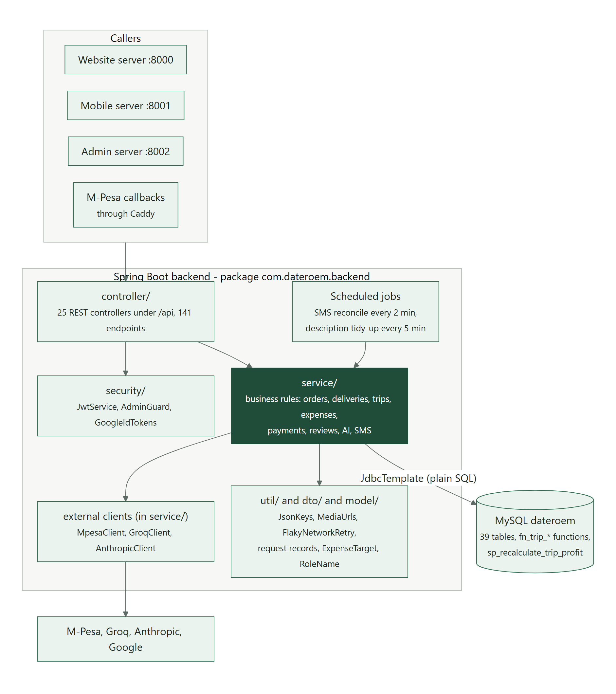
Figure 1: Inside the backend: who calls it and how it is layered

2.2 Technology
Item | Version or detail
Language and runtime | Java 17
Framework | Spring Boot 3.2.5 (spring-boot-starter-web)
Database access | Spring JDBC (JdbcTemplate) with plain SQL - no ORM; MySQL Connector/J
Passwords | spring-security-crypto, BCrypt
Sign-in tokens | jjwt 0.12.6 (HS256 JSON Web Tokens)
Developer convenience | spring-boot-devtools (restarts when classes are recompiled)
Build tool | Maven (backend/pom.xml)
Location | /root/fathersProject/backend (inside WSL Ubuntu)
Table 1: Backend technology

2.3 Design conventions
- Plain SQL everywhere. Each service owns its SQL statements. Column names in the database are Title_Case; results are converted to camelCase JSON keys by util/JsonKeys.camelCaseKeys.
- Soft delete. Nothing is physically deleted. Rows carry Is_Deleted, Deleted_By and Deleted_At; deleted products, campaigns and trees can be restored from a "bin".
- Audit trail. Every write that matters inserts a row into AUDIT_LOGS with who did it (Actor_ID) and what changed.
- Newest first. Lists are ordered by id descending. A limit parameter of null means "all", used by the desktop app.
- Clear errors. Problems are raised as ResponseStatusException with a readable message (for example "Not enough stock: ..."). The Python servers pass that message on to the user.
- Money-safe external calls. Network retries never resend a payment that may already have reached Safaricom (see External services and network resilience).

3 Source code layout
All Java code is under backend/src/main/java/com/dateroem/backend/. Configuration is in backend/src/main/resources/application.properties.
Package or file | What it contains
BackendApplication.java | Entry point. Enables scheduling, forces IPv4 and turns off DNS caching so retries reach a working address.
controller/ (26 files) | REST endpoints under /api. Thin: read the request, check the caller, call a service.
service/ (29 files) | Business rules and SQL. Also the external clients MpesaClient, GroqClient and AnthropicClient.
security/ | JwtService (issue and check tokens), AdminGuard (admin-only gate, and the Marketer-or-admin gate for the Bulk Orders pictures), GoogleIdTokens (verify Google sign-in), MobileDeviceFilter (approved-phone check on every mobile request), DesktopClientFilter (approved-computer and admin check on every desktop request).
dto/ | Request and response records (for example CreateOrderRequest, SendMoneyRequest, MpesaCallbackRequest).
model/ | ExpenseTarget (every payable category and its table) and RoleName (the seven roles).
util/ | JsonKeys (camelCase), MediaUrls (image key to URL and back), FlakyNetworkRetry (safe retries), EmailAddresses (email format and mail-domain check).
resources/application.properties | All settings, most of them overridable by environment variables.
resources/mpesa/SandboxCertificate.cer | Safaricom sandbox public certificate for B2C.
Table 2: Backend packages

4 Security model

4.1 Accounts and roles
Every person has one row in USERS with a role from ROLE. The roles are Customer, Marketer, ProductStaff, Worker, Manager, Admin and SuperAdmin (an older "Employee" role is retired). Passwords are stored as BCrypt hashes. An account can be disabled by an admin (USERS.Status), which blocks sign-in.

4.2 Sign-in tokens
A successful sign-in returns a JWT signed with HS256 by security/JwtService.java. Its subject is the user id; it expires after app.auth.jwt-expiry-hours (720 hours by default). A desktop-app sign-in expires after app.auth.desktop-jwt-expiry-hours (12 hours) instead. Clients send it as Authorization: Bearer <token>.
Tokens issued before app.auth.tokens-valid-from (AUTH_TOKENS_VALID_FROM, 2026-10-18T08:30:00Z) are refused. The clean-up before going live (18 October 2026) renumbered the accounts, so an older token could otherwise name whichever account has that number now; everyone signed in once more. Moving the setting forward signs everybody out again.
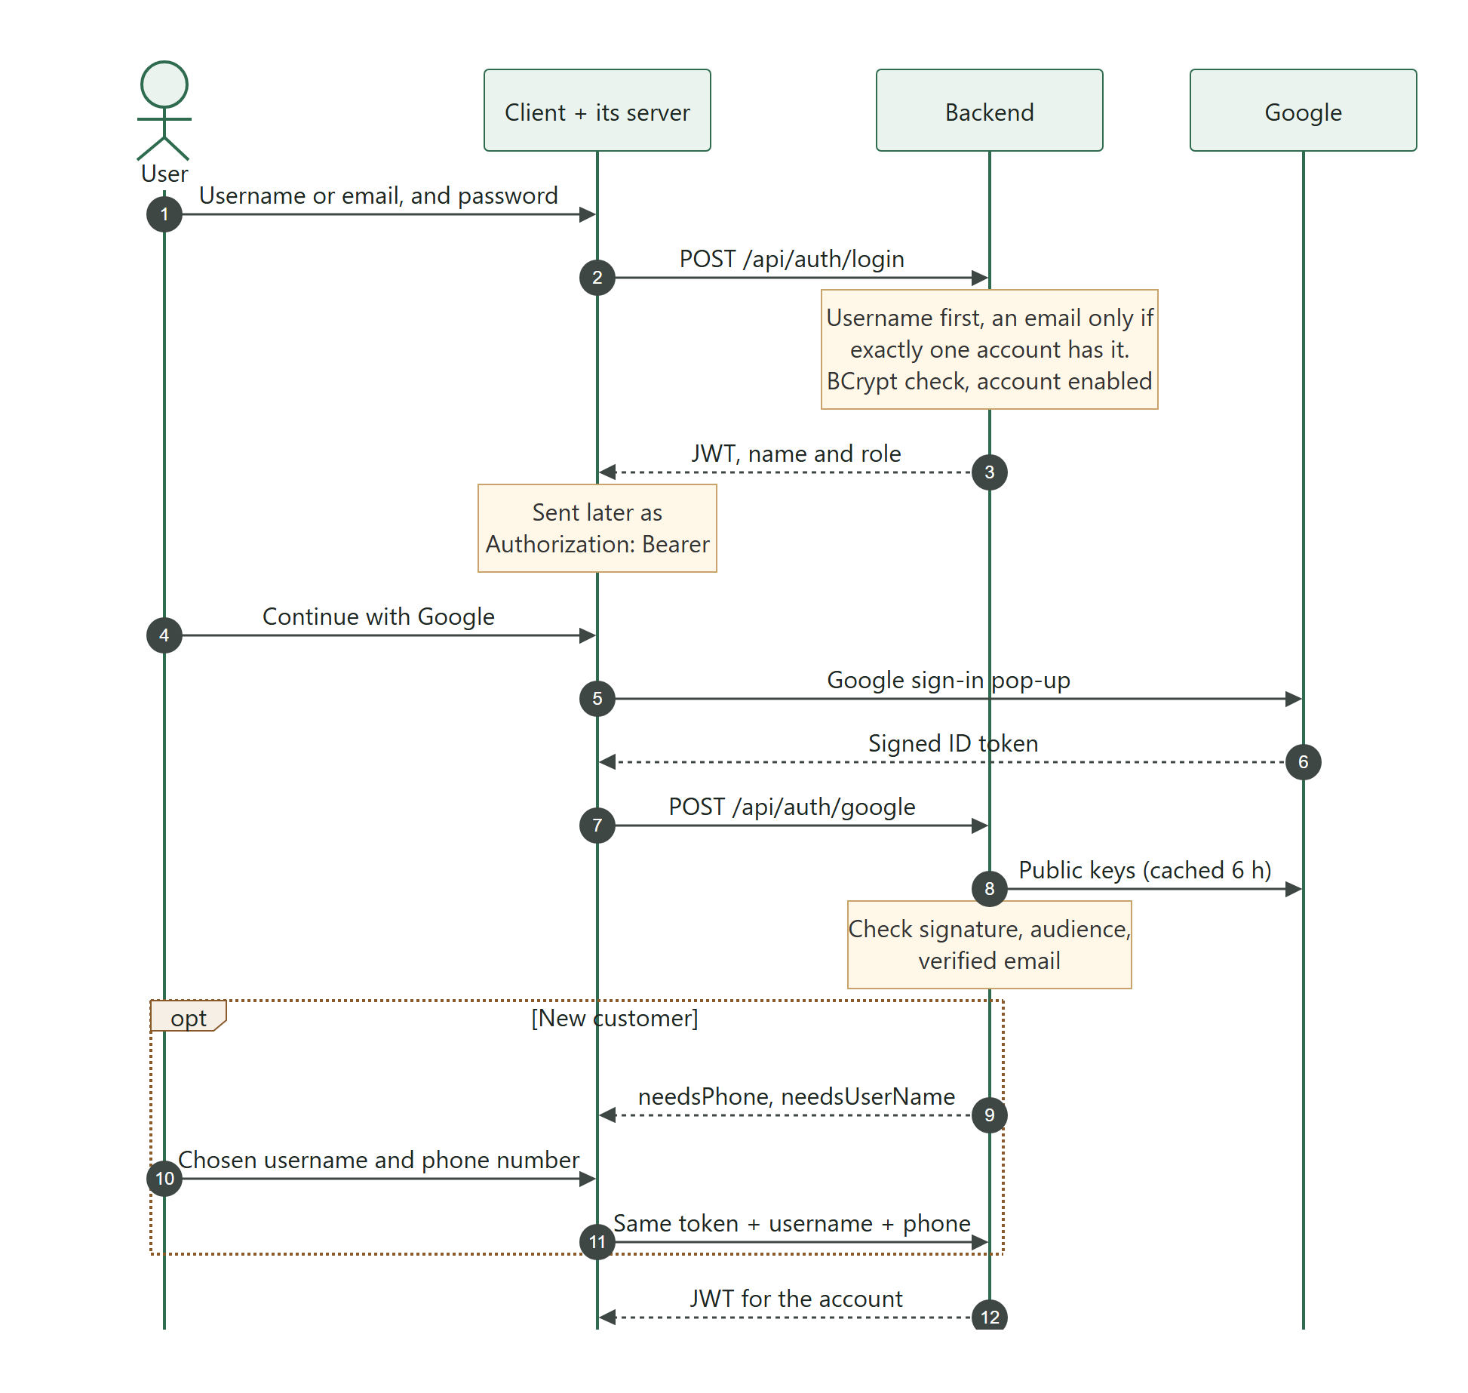
Figure 2: Signing in with a password or with Google

4.3 Approved phones (mobile app)
Since 3 October 2026 an account can use the mobile app on one approved phone at a time, in the way a streaming service knows your devices. Copying the app to a second phone, or giving a password to someone else, is no longer enough to use the account from another phone: that phone waits until the SuperAdmin approves it.
- The phone's identity. On first sign-in the app creates a private key inside the phone's secure hardware (the Android Keystore, using the StrongBox chip when the phone has one). The key cannot be copied out of the phone. The backend stores only the matching public key and its SHA-256 fingerprint in USER_DEVICES.
- Proof at sign-in. The app first asks for a one-time value (GET /api/auth/device/challenge, valid 2 minutes, usable once), signs it with the key (ECDSA P-256 with SHA-256) and sends the signature with the username and password. DeviceService checks the signature before anything else.
- Who is approved. An account that has never had an approved phone gets its first phone approved automatically, so nobody already using the app is locked out. Any later phone is saved as waiting (PENDING) and the sign-in is refused with DEVICE_PENDING until the SuperAdmin approves it in the desktop app (Users > Phones; any admin could until 5 October 2026). Approving a second phone for the same account requires "replace", which blocks the old one in the same step.
- The token names the phone. A token issued to a phone carries a did claim (the USER_DEVICES.Device_ID). Website tokens have no such claim and are unaffected; desktop tokens name a computer instead (see Approved computers).
- Checked on every request. The mobile server marks every call it makes with X-Client: mobile. security/MobileDeviceFilter.java runs before any controller for those calls and refuses (401) a token that names no phone, a phone that is no longer approved, or a disabled account. Blocking a phone therefore cuts it off on its very next request, not when its token expires.
- The acting user comes from the token. For mobile calls the filter replaces X-Actor-User-Id with the user id inside the verified token, whatever the app sent. Nobody can act as another person by changing a number.

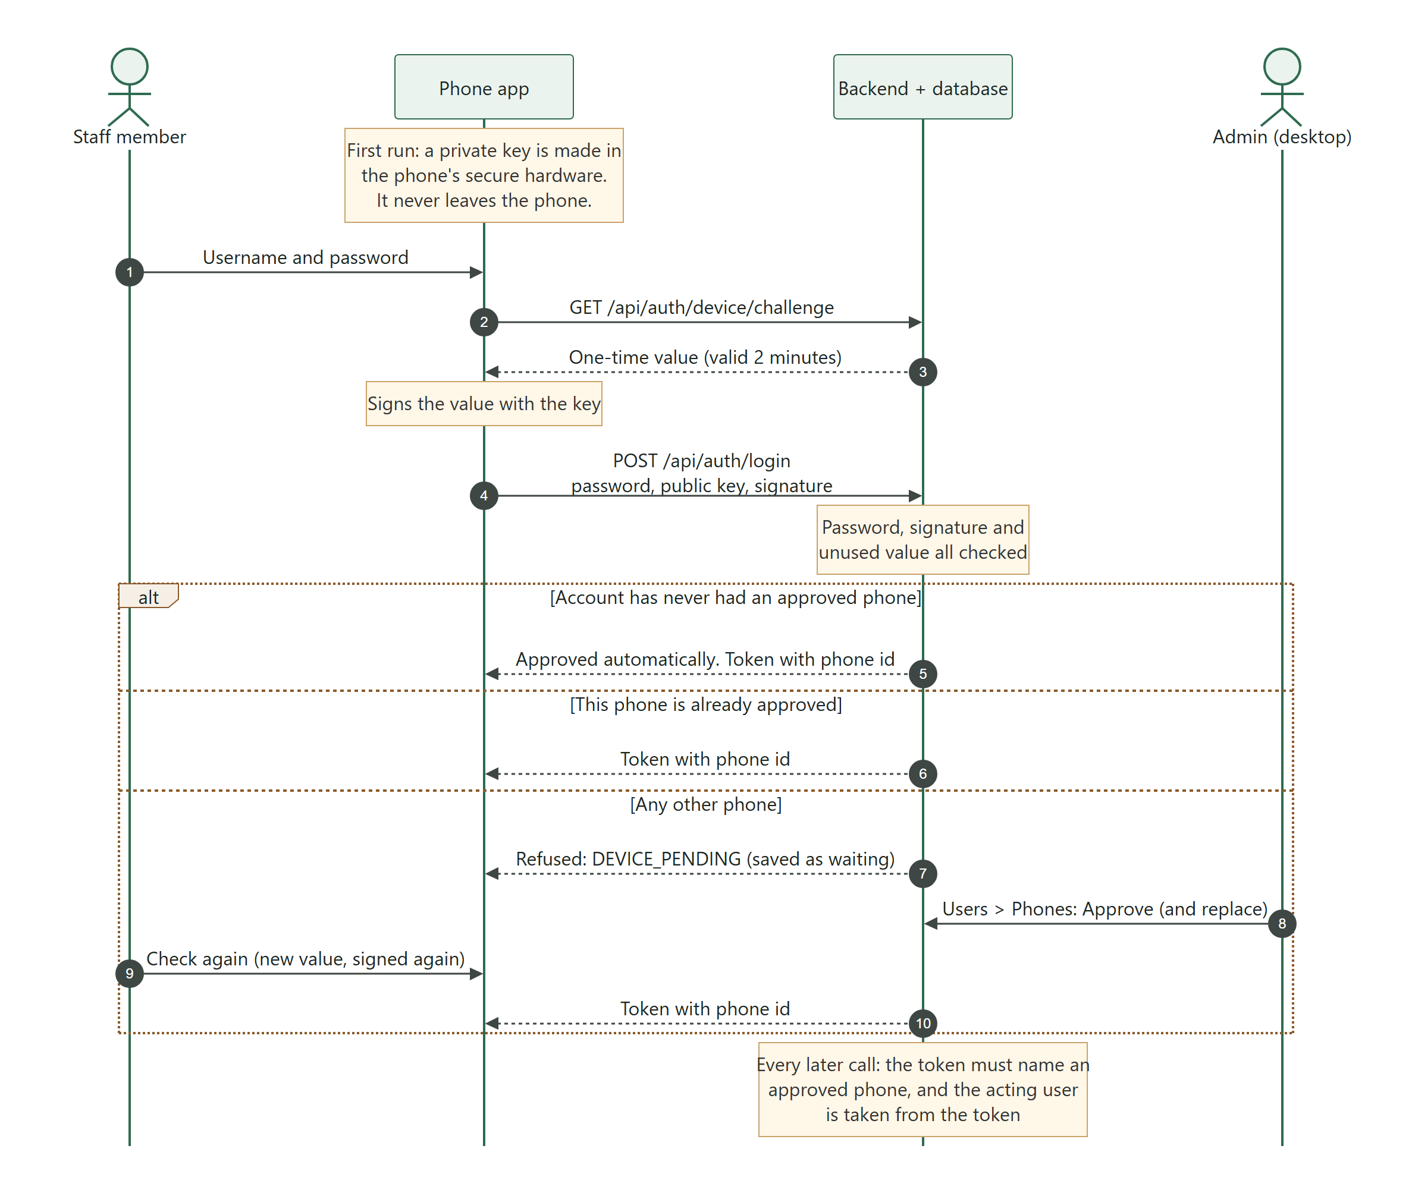
Figure 3: Signing in on a phone, including a phone that waits for approval
The phone list and its actions are GET /api/devices, POST /api/devices/{deviceId}/approve?replace= and POST /api/devices/{deviceId}/revoke: admins may list, and only the SuperAdmin may approve, reject or block (AdminGuard.requireSuperAdmin). Each approval, rejection, block and automatic first-phone approval is written to AUDIT_LOGS (target table USER_DEVICES). The fingerprint lock that protects the app on the phone itself is described in the Mobile Application document (DWS-MOB-02).
Where to adjust: The 2-minute life of the one-time value is CHALLENGE_TTL_MS in service/DeviceService.java. The paths that do not need a phone token (sign-in, the one-time value and the health check) are OPEN_PATHS in security/MobileDeviceFilter.java. Turning the whole check off is not a setting: remove the X-Client header in the mobile server's app/core/backend_client.py only for a deliberate, temporary reason.

4.4 Approved computers (desktop app)
Since 5 October 2026 the desktop app no longer has to run on the computer the servers run on: "a standalone application that has higher privilege that can work even if the backend is not in the same machine". The same idea as approved phones keeps that safe.
- The computer's identity. On first sign-in the desktop app has Windows create a P-256 key in its key store - in the TPM security chip when the computer has one - that can never be exported. The backend keeps only the public key and its SHA-256 fingerprint in USER_COMPUTERS (migration 031).
- Proof at sign-in. The app asks for a one-time value (GET /api/auth/computer/challenge, 2 minutes, usable once), signs it and sends the signature with the username and password. The admin server marks the call X-Client: desktop, and AuthController.login then uses AuthService.desktopLogin: the password is checked, the account must be enabled and Admin or SuperAdmin (any other role is refused before its computer is recorded), then ComputerService checks the signature.
- Who is approved. One approved computer per account (the database refuses a second). The SuperAdmin's own first computer is approved automatically, since nobody else could approve it; every other computer - an Admin's first one included - is saved as waiting and refused with COMPUTER_PENDING until the SuperAdmin approves it in the desktop app (Users > Computers). Approving another computer for the same account needs "replace", which blocks the old one.
- The token names the computer. A desktop token carries a pc claim (USER_COMPUTERS.Computer_ID) and lasts 12 hours.
- Checked on every request. security/DesktopClientFilter.java runs before any controller for X-Client: desktop calls and refuses (401) a token that names no computer (SESSION_EXPIRED), a computer that is no longer approved, a disabled account or one that is no longer Admin or SuperAdmin (COMPUTER_REVOKED). Blocking a computer cuts it off on its very next request.
- The acting user comes from the token. As on mobile, the filter replaces X-Actor-User-Id with the user in the verified token. Before this, the desktop path took whatever acting user the app sent - "Send Money" included.

The computer list and its actions are GET /api/computers, POST /api/computers/{computerId}/approve?replace= and POST /api/computers/{computerId}/revoke. They answer only requests that came through the desktop filter; admins may list, and only the SuperAdmin may approve, reject or block. Each step is written to AUDIT_LOGS (target table USER_COMPUTERS).
Where to adjust: Desktop sign-in length: app.auth.desktop-jwt-expiry-hours (AUTH_DESKTOP_JWT_EXPIRY_HOURS, 12). The paths that need no computer token are OPEN_PATHS in security/DesktopClientFilter.java; the one-time value's life is CHALLENGE_TTL_MS in service/ComputerService.java. The wrong-password limit for desktop sign-in lives in the admin server (Admin Server document).

4.5 One SuperAdmin
"there can only be one super admin ... the one who permits phones desktops is the superadmin" - since 5 October 2026 there is exactly one SuperAdmin, and Admins keep everything else they had. UserService enforces it for every client:
- No account can be created as SuperAdmin (409).
- Only the SuperAdmin can change the SuperAdmin account (403), and it can't be disabled (409) or given another role (409 - there must always be one).
- Only the SuperAdmin can give the SuperAdmin role (403). Doing so hands it over: the other account becomes SuperAdmin and the giver becomes Admin in the same transaction, with an audit line.
- Only the SuperAdmin can change a username (403 otherwise) - "one might have used a wrong username when creating". The new one follows the sign-up rule (400) and must not be taken (409), and the change is written to the audit log ("Username changed from ... to ..."). Nothing else changes: tokens, phones and computers name the user id, not the username.
- AdminGuard.requireSuperAdmin guards approving, rejecting and blocking phones and computers.

4.6 How a caller is identified
- Signed-in token - endpoints that read Authorization and validate the JWT: authentication, website orders, reviews, the AI chat, SMS ingest and user management.
- Approved-phone token - every request through the mobile server (see above). The acting user is the user in the token.
- Approved-computer token - every request through the admin server (see Approved computers). The acting user is the user in the token, and the account must still be Admin or SuperAdmin.
- Acting user id - most staff endpoints read an X-Actor-User-Id header. On mobile and desktop requests it is set from the verified token, whatever the app sent. The backend uses it for the audit trail and, where noted, for an admin role check.
- Admin enforced in the backend - retiring and bringing back products (9 October 2026), user management, phone approval, the database browser, loans and capital changes, Pay Loan, Send Money and its confirmation, dropping orders, the refunds list, review moderation and deleting other people's expense entries. Marketer or admin enforced: changing the Bulk Orders pictures (9 October 2026, AdminGuard.requireShowcaseEditor). SuperAdmin enforced: approving, rejecting and blocking phones and computers, and changing the SuperAdmin account or role. Other role limits are applied by the apps, which hide screens by role.

Security: Closed on 3 October 2026 for the mobile path: the acting user on a mobile request is taken from a verified token issued to an approved phone, so a person who knows an admin's user id can no longer act as that admin through the tunnel.
Closed on 5 October 2026 for the desktop path: every call through the admin server needs a token issued to an approved computer of an Admin or SuperAdmin, and the acting user is taken from it. This is what allows the admin server to be reachable from other computers once the servers move to a provider (see the Production Go-Live Checklist, DWS-CFG-02).
Reviewed on 9 October 2026 before going public: a payment result is acted on only after Safaricom's status query confirms it (TransactionService.handleMpesaCallback); OrderService.createOrder refuses an empty cart and any quantity below 1 and adds up repeated products before the stock check; the mobile sign-in refuses customer accounts (RoleService.isStaff); payout amounts must be positive whole shillings up to KES 1,000,000 and Send Money or a loan payment to a number other than the one on file needs the SuperAdmin; a failure found by the status query cancels the order and returns its stock.

4.7 What is public
Port 8080 is never exposed directly. The Caddy router only forwards /api/dateroem-mpesa-callback/* - and, for production, the same handlers at /api/dateroem-payments/* (8 October 2026; Safaricom rejects addresses with "mpesa" in them) - to it, so Safaricom can deliver payment results. Everything else reaches the backend from the three Python servers running on the same computer. The admin server (8002) is not on the tunnel either; when it is given a public HTTPS address, the approved-computer check above is what protects it.

5 Feature modules
Each module below lists its files, the tables it uses and the rules worth knowing before changing it. The full endpoint list is in Appendix A.

5.1 Accounts, sign-in and users
Item | Details
Files | AuthController, AuthService, UserController, UserService, RoleController, RoleService, DeviceController, DeviceService, ComputerController, ComputerService, security/*
Tables | USERS, ROLE, USER_DEVICES, USER_COMPUTERS, PHONE_VERIFICATIONS
Used by | All three clients (sign-in); desktop app (user management, phone and computer approval)

- Website sign-up (/api/auth/register) always creates a Customer and requires a phone number, normalised to the 07XXXXXXXX form. The person chooses the username: 3 to 30 characters, no spaces and no @ (so a username can never look like an email), and not already taken (409). Staff accounts made by an admin are not held to this rule.
- An email is optional at sign-up. When given, util/EmailAddresses checks that it is well formed (a "+tag" such as name+shop@gmail.com is fine) and that its domain can receive mail: it asks DNS for the domain's MX records, or failing those an address record (2-second time limit, one retry), and remembers each domain's answer for an hour. A domain that refuses mail ("null MX") or does not exist is rejected with a readable message (400). If DNS cannot be asked at all (no internet), the address is accepted rather than turning a customer away. An email already used by another account is refused (409).
- Sign-in (/api/auth/login) accepts the username or the email. The username is tried first, exactly as before; the email is used only when no username matches and exactly one account has that address. If several accounts share it, the person is asked to sign in with their username.
- Colour theme (since 20 October 2026, migration 037): USERS.Theme is forest (the default), dark or light. Every sign-in answer (AuthResponse.theme) and GET /api/auth/me carry it; PUT /api/auth/me/theme with {"theme": ...} saves it for the signed-in, enabled account (AuthService.saveTheme; anything else is refused with 400). The website, the phone app and the desktop app read it when they start or someone signs in - a device already open keeps its theme until then, on purpose ("no one is affected when working").
- Order tickets (since 23 October 2026, migration 038): ORDERS.Ticket_Code, like DW-7K3Q9P, is drawn at random by OrderTickets when an order is made - website checkout, a light delivery or a bulk order opened by staff - and older orders get one when the backend starts. Order lists, a trip's deliveries, the pending groups, refunds and Website Payments carry ticketCode, and the assistant names a customer's orders by it. GET /api/orders/track?ticket=&phone= is open (no sign-in) for orders made by a Customer account: the last 3 digits of the account's phone must match; five wrong answers lock that ticket for 30 minutes and the endpoint answers at most 60 look-ups a minute (429). A customer's order shows the driver's first name and the number plate only when LIGHT_DELIVERIES.Share_Driver is set; PATCH /api/deliveries/light/{id}/share-driver sets it on a delivery and the orders under it (audited), an order put under a delivery follows that delivery, and an order sent back to the pool is hidden again.
- Profiles and passwords (since 24 October 2026, migration 039): ProfileService changes the signed-in person's name and email (PUT /api/auth/me/profile - the current password when the email changes), photo (PUT /api/auth/me/photo - only a profiles/u<own id>-<random>.jpg key the servers saved) and password (POST /api/auth/me/password - at least 8 characters with letters and numbers, not the username; five wrong current passwords in 15 minutes and the account waits). USERS.Password_Changed_At is written from Java in whole seconds and UTC (the connection runs with serverTimezone=UTC) and read back as a Timestamp by AccountSecurity, which JwtService asks on every token: a token issued before it is refused, so a change signs the account out everywhere else - the device asking gets a new token in the answer. Nobody can read a password; POST /api/users/{id}/reset-password (admins; only the SuperAdmin resets an Admin; the SuperAdmin's own only from their profile) sets a temporary one, shown once, and Must_Change_Password - PasswordChangeFilter then answers PASSWORD_CHANGE_REQUIRED to everything but /api/auth/me and /api/auth/me/password. A customer's own phone number changes only with the SMS code routes; a staff number only through Users (it receives payouts). Sign-in answers carry mustChangePassword and idleLockMinutes (APP_SETTINGS idle_lock_minutes, 5 to 120, set by the SuperAdmin with PUT /api/settings/idle-lock; POST /api/auth/me/verify-password unlocks the desktop app).
- Orders near their promised date (since 24 October 2026): DeliveryDeadline marks an order still waiting for a delivery DUE_SOON in the last quarter of the time it was promised (3 weeks, or 3 months for large items) and never later than 5 days before the date, and LATE once the date has passed; the pending groups and the unassigned pool carry promisedOn, daysLeft and deadlineRisk (groups their most urgent), and the Home overview counts them.
- Home for Admins and the SuperAdmin (24 October 2026): GET /api/insights/overview (OverviewService, admins only) answers users by role, products in the shop / retired / out of stock / deleted, campaigns running / upcoming / ended with photos and videos, trips, and the orders waiting (due soon, late, to reassign) in one call. The company card is APP_SETTINGS company_name, company_motto and company_code - GET /api/settings/company for anyone signed in, PUT for the SuperAdmin.
- Worker details (since 24 October 2026, migration 040): WorkerService keeps each staff member's ID or passport number, KRA PIN, NSSF and SHA numbers, next of kin, driving licence and photos of their documents. The staff member reads and saves their own (GET and PUT /api/workers/me, POST /api/workers/me/documents/{typeKey} - customers are refused); values are checked by kind (text, number, date, phone; at most 120 characters) and photos must be JPEGs of at most 3 MB. Once every required item is there the record becomes SUBMITTED; a change after VERIFIED sends it back to SUBMITTED. Admins see only where each one stands (GET /api/workers - counts, no numbers); the SuperAdmin alone opens the details and photos (GET /api/workers/{userId}, .../documents/{documentId} - each opening written to AUDIT_LOGS), marks them VERIFIED or NEEDS_CHANGES with a note (POST .../verify), deletes a photo or everything (DELETE), and adds or stops asking for fields and document types (/api/workers/fields, /api/workers/doc-types).
- DataCipher (security/) encrypts the fields marked sensitive and every document photo with AES-256-GCM (a fresh 12-byte nonce each time, stored in front of the ciphertext) using the 32-byte key app.workers.data-secret (base64; WORKER_DATA_SECRET overrides it). Without a key, worker details answer 503 "not set up on the server yet". The key must be copied - never made new - when the backend moves: what was saved can only be read with it.
- Google sign-in (/api/auth/google) verifies the Google ID token against Google's public keys (cached for 6 hours), checks the audience equals app.google.client-id and that the email is verified. Someone new gets needsPhone and needsUserName back; the website then sends the same token again with the phone number and a username of their choice (same rules as sign-up). The Google account id is stored in USERS.Google_Sub; such an account has no password. A Google email already used by an account here is never joined to it automatically (409).
- Phone numbers confirmed by an SMS code (since 17 October 2026, migration 036) - "one may give a phone number not theirs ... push a code to the phone number they placed so that its verified". PhoneVerificationService makes a 6-digit code (kept only as a hash), valid 10 minutes with 5 tries, and SmsSender sends it through Africa's Talking. At sign-up a right code (/api/auth/phone/verify) returns a one-time proof, valid 30 minutes, that /api/auth/register and /api/auth/google must carry; the account is then saved with Phone_Verified_At. A signed-in customer (/api/auth/me/phone/...) confirms their number once, and it becomes the account's number (audit log PHONE_VERIFIED).
- Who is asked: Customer accounts, when SMS is set up (app.sms.provider africastalking with a username and key, or test) and the number is on a network in app.sms.networks (util/KenyanNetworks tells from the prefix; Airtel only for now, because the shared sender reaches only Airtel). Any other number gets {codeNeeded: false} and is taken as typed, as before. OrderService.createOrder refuses (403) an unconfirmed customer who should have a code, so the website asks before the first order; /api/auth/me says phoneCodeRequired.
- Limits: one code a minute, 3 per 15 minutes and 8 a day per number; 8 a day per account; 200 an hour in all. When Africa's Talking cannot send (an empty balance, a gateway error, no connection), codes pause for 10 minutes and customers carry on without one - nobody is kept from signing up or paying; the log says "phone codes paused ... top up". A number Africa's Talking calls invalid is refused (400). The code is never written to the log, and numbers in the log are masked (07XX XXX 123).
- Admins create staff accounts with any role except SuperAdmin, edit them and enable or disable them (the SuperAdmin account only by the SuperAdmin - see Security model, One SuperAdmin). Exactly one account may be flagged Can_Sync_Sms (the company phone) - setting it on one account clears it from the others.
- Mobile sign-in also proves which phone is used and is refused for a phone that is not approved (see Security model, Approved phones). AuthService.login takes this path whenever the request carries a device proof; the website sends none. Desktop sign-ins (X-Client: desktop) go through AuthService.desktopLogin and need a computer proof (see Approved computers).
- Phones: admins list every phone that has signed in (waiting ones first); the SuperAdmin approves a waiting phone (with replace when the account already has one), rejects a waiting phone or blocks an approved one. A blocked phone can be approved again later.
- Computers: the same for the computers the desktop app is used on, from the desktop app only.

5.2 Products
Item | Details
Files | ProductController, ProductService, DescriptionFormatter, util/MediaUrls
Tables | PRODUCTS, INVENTORY_MOVEMENT, TREES (source), ORDER_ITEMS (popularity)

- Stock is a decimal that means pieces or board feet depending on PRODUCTS.Unit. Body_Feet_Per_Unit is the size of one piece and decides the delivery estimate.
- PRODUCTS.Image stores only a relative key such as products/rose-wood.jpg; MediaUrls.resolve adds app.media.base-url. Editing a product without a new image keeps the existing one.
- "Most ordered" comes from the database function fn_product_order_count.
- Long descriptions (up to 10,000 characters) are kept exactly as typed. DescriptionFormatter asks the AI for a tidier copy (Description_Display) in the background and throws it away unless every number and fact still matches. A sweep every 5 minutes catches anything missed.
- Marketer_Note is the short badge shown on the product card (for example "Most ordered - only 2 left").
- Retiring (since 9 October 2026, migration 033): POST /api/products/{id}/retire and /unretire (Admin or SuperAdmin, checked here) take a product off the shop or bring it back, recorded in Is_Retired, Retired_At, Retired_By and the audit log. The shop's catalogue, product page, "most ordered" and checkout leave retired products out; the admin apps ask with includeRetired=true and see them marked. GET /api/products/depleted lists products that have run out (stock 0 or less) and are not retired: the admins' "needs attention" list. Stock and existing orders are never touched.

5.3 Marketing campaigns
Item | Details
Files | MarketingController, MarketingService
Tables | CAMPAIGN, CAMPAIGN_PRODUCTS, CAMPAIGN_AUDIENCE, CAMPAIGN_LOGS

A campaign has a name, channel (or All), status, dates and one media item - an image or a video (Media_Type). Media keys resolve the same way as product images; MarketingService always stores the bare key (MediaUrls.toKey), so editing a campaign without choosing new media keeps its image or video. Campaigns are linked to the products they promote.
- PUT /api/marketing/campaigns/{campaignId}/products replaces the whole set of linked products in one step (body {"productIds": [...]}; an empty list removes them all). The list may name only products that exist and are not in the bin (400 otherwise); links to products that are already in the bin are left as they are, so restoring such a product brings its campaign back. An unknown or deleted campaign gives 404. Each change writes an AUDIT_LOGS line "Campaign products: <names>".
- The website shows a campaign only while it is running: Active, today within its dates, and with at least one linked product not in the bin. That rule lives in the website server (DWS-WEB-01) and, for the assistant, in AiChatService.buildPromotionContext.

5.4 Orders and checkout
Item | Details
Files | OrderController, OrderService, MpesaClient
Tables | ORDERS, ORDER_ITEMS, INVENTORY_MOVEMENT, PRODUCTS, LIGHT_DELIVERIES, PRODUCT_PAYMENTS, DELIVERY_AREAS

- The customer chooses a delivery area; the backend checks it is active.
- Every product row in the cart is locked (SELECT ... FOR UPDATE) and checked against stock. A shortfall rejects the whole order with a message naming the products.
- The order, its items, a negative stock movement and a PENDING delivery record are written. The delivery estimate is 3 weeks, or 3 months if any item is larger than 500 body feet per piece.
- An M-Pesa STK push is sent for the total. If it cannot be sent, the whole order is rolled back - there is no pay-on-delivery.
- The payment is settled by the Safaricom callback or by a status query when the order page polls (at most once every 8 seconds per payment). Success marks the order PAID; failure cancels it and returns the stock.
- The receipt (since 17 October 2026, migration 035): a callback's M-Pesa receipt is stored in PRODUCT_PAYMENTS.Mpesa_Receipt (and still appended to the description); a payment settled by the status query has none, because that query returns no receipt. GET /api/orders/payments (admin) lists the website payments with their receipts, and the pending-orders data (DeliveryService.pendingOrderGroups) carries each order's receipt.

Customers never see the real Order_ID; they see their own 1st, 2nd, 3rd order number. Admins can drop an order that is not yet on a trip: the stock is returned, the cancellation cost is kept and the refund is paid later through Send Money (category ORDER_REFUND).
Where to adjust: Delivery estimate rules: constants LARGE_ITEM_THRESHOLD_BODY_FEET, LARGE_ITEM_SLA_MONTHS and SMALL_ITEM_SLA_WEEKS at the top of service/OrderService.java.
Status-query spacing: RECONCILE_MIN_INTERVAL_MS in the same file (Safaricom allows 30 requests a minute).

5.5 Deliveries
Item | Details
Files | DeliveryController, DeliveryService, AnthropicClient (scan)
Tables | LIGHT_DELIVERIES, BULK_DELIVERY, BULK_TRIP_PRODUCTION_DESCRIPTION, ORDERS, TRIP, VEHICLE

- Light deliveries carry ordinary website orders. Every order gets one at checkout. Admins see pending orders grouped per customer and delivery area, gauged LIGHT, BULK or COMBINED by size, and put a group on a trip - into a new or existing light delivery (optionally named), or riding along with a bulk delivery as a "side quest".
- At hand-over the worker records "received by" and the customer's signature (stored as an image data URL). Settling a delivery closes the delivered orders and sends the rest back to the pending pool flagged Needs_Reassignment with the reason.
- Bulk (heavy) deliveries are negotiated mostly offline. A heavy order creates an ORDERS row and a BULK_DELIVERY row together. Production description lines (type, measurement, body feet, total, optional photo) can be typed or read from a photo of a handwritten sheet by the AI scan. Finalizing records the hard and soft cash amounts and recalculates the trip.

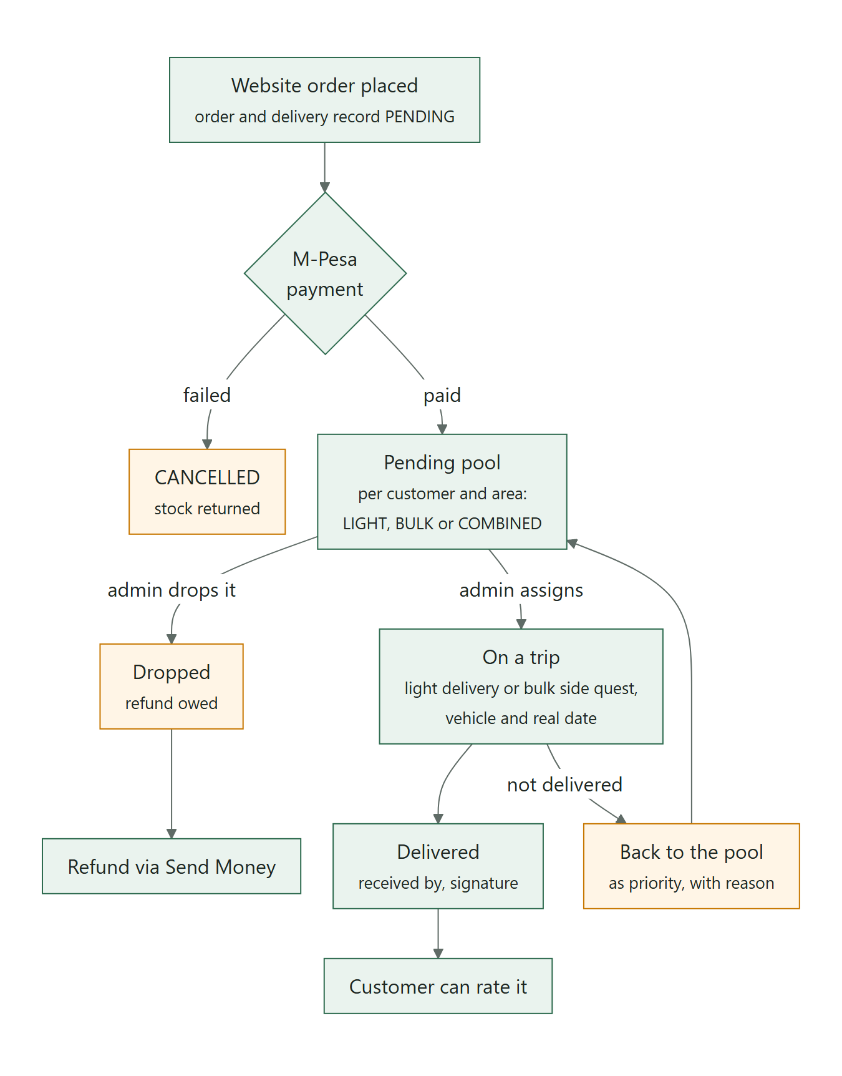
Figure 4: Life of an order from checkout to delivery

5.6 Trips
Item | Details
Files | TripController, TripService
Tables | TRIP, PROFIT, LIGHT_DELIVERIES, BULK_DELIVERY, LOAN, PRODUCT_PAYMENTS

- A trip is the hub that trees, expenses, loans, capital and deliveries attach to. Only one trip may be open at a time - a new trip is refused until the open one is finalized.
- Finalizing requires no ACTIVE loans and no unfinished bulk deliveries. Undelivered orders can be dropped back to the pending pool as priority. The total payment and profit are then recalculated (sp_recalculate_trip_profit) and the end date set.
- Deleting a trip returns its orders to the pending pool without priority.
- Total payment = product payments + bulk delivery amounts for the trip.

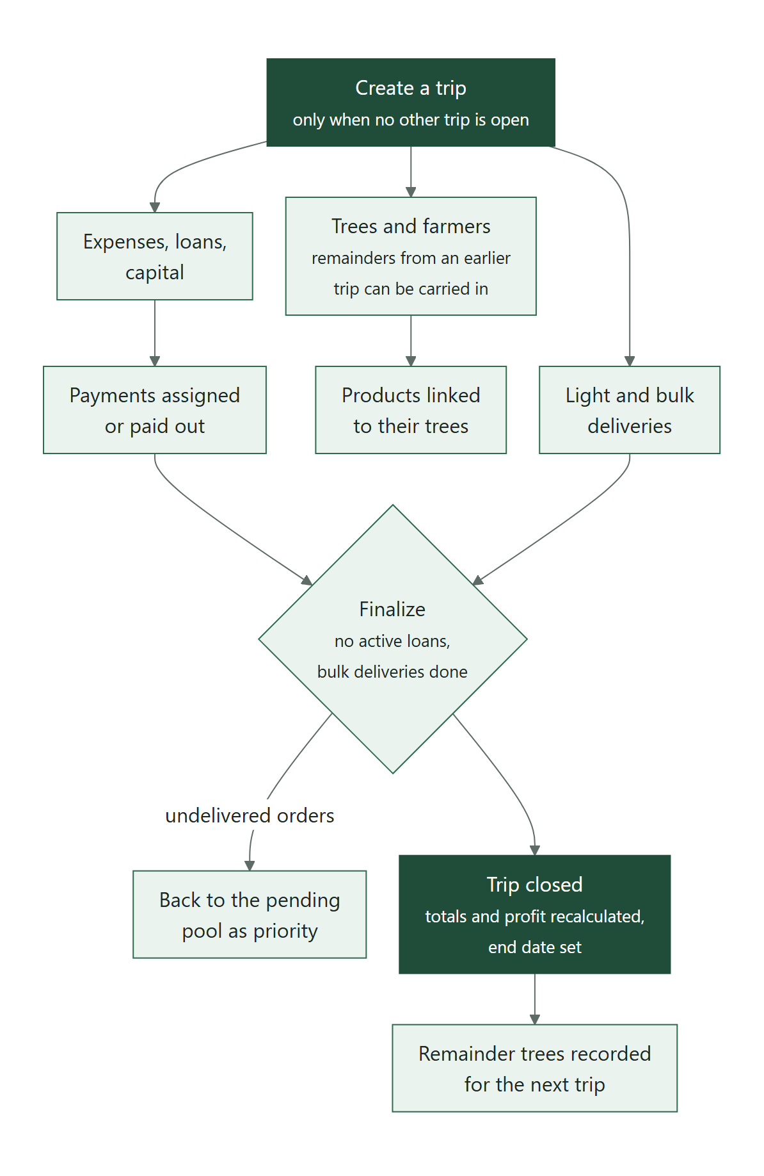
Figure 5: The trip lifecycle

5.7 Trees, farmers and farmer payments
Item | Details
Files | TreeController, TreeService, FarmerController, FarmerService, RemainderTreeController, RemainderTreeService, FarmerPaymentController, FarmerPaymentService
Tables | TREES, FARMER, REMAINDER_TREES, FARMER_PAYMENTS

Trees are registered per trip against a farmer and household, with GPS coordinates. Trees left over at the end of a trip are recorded as remainder trees, which a later registration can claim (each remainder only once). Products point at the tree registration they came from. A farmer payment must name a tree that belongs to that farmer. "Top suppliers" ranks farmers by trees supplied across all trips.

5.8 Expenses
Item | Details
Files | ExpenseController, ExpenseService, model/ExpenseTarget
Tables | TRANSPORT, COMMUNICATIONS, MACHINE_EXPENSES, OTHER_EXPENSES, PERMITS, ACCOMODATION, SALARIES, FARMER_PAYMENTS

Staff record an expense as an entry (a "holder") that is not yet paid. It becomes paid when an admin assigns an incoming payment to it or pays it with Send Money. Per-trip totals come from the database functions fn_trip_*_total, so the trip view stays cheap. Five categories record whether the money was soft cash (M-Pesa) or hard cash. A user can delete only their own unpaid entries; admins can delete any unpaid entry.
Where to adjust: To add a new expense category: create the table (with Amount, Reference_ID, Created_At, Trip_ID, Financial_Transaction_ID and the soft-delete columns), add it to model/ExpenseTarget.java, add its total function to the profit calculation in the database, and add it to the mobile ui/expenses/ExpenseCategory.kt and the desktop expenses tab.

5.9 Loans and capital
Item | Details
Files | LoanFinanceController, LoanFinanceService
Tables | LOAN, LOAN_REPAYMENTS, CAPITAL, TRIP (hard and soft cash)

Admins record loans and capital per trip. A repayment counts as paid only when it really is: a manual entry is paid at once, a Send Money repayment only after M-Pesa confirms it (a failed one is removed). Loan status (for example ACTIVE, PAID, written off) controls whether a trip can be finalized.

5.10 Transactions and payments
Incoming payments (STK pushes sent by staff and M-Pesa SMS read from the company phone) become rows in FINANCIAL_TRANSACTION. Admins claim batches, see suggested matches and assign each payment to the expense entry it paid for. Outgoing payments (Send Money, Pay Loan, refunds) are sent through M-Pesa B2C and confirmed automatically. The full flows, safeguards and the production switch are in the M-Pesa Payments document (DWS-BE-03).
Item | Details
Files | TransactionController, TransactionService, MpesaClient, MpesaCallbackController
Tables | FINANCIAL_TRANSACTION and every table listed in ExpenseTarget

5.11 SMS queue (offline M-Pesa payments)
Item | Details
Files | SmsQueueController, SmsQueueService
Tables | SMS_QUEUE, FINANCIAL_TRANSACTION

The company phone forwards every M-Pesa SMS. Only the account flagged Can_Sync_Sms may post them. A message whose receipt is already recorded is linked (MATCHED); otherwise a new unassigned transaction is created (PENDING_ASSIGNMENT) for an admin to assign. The same receipt is never queued twice. A sweep every 2 minutes reconciles anything missed.
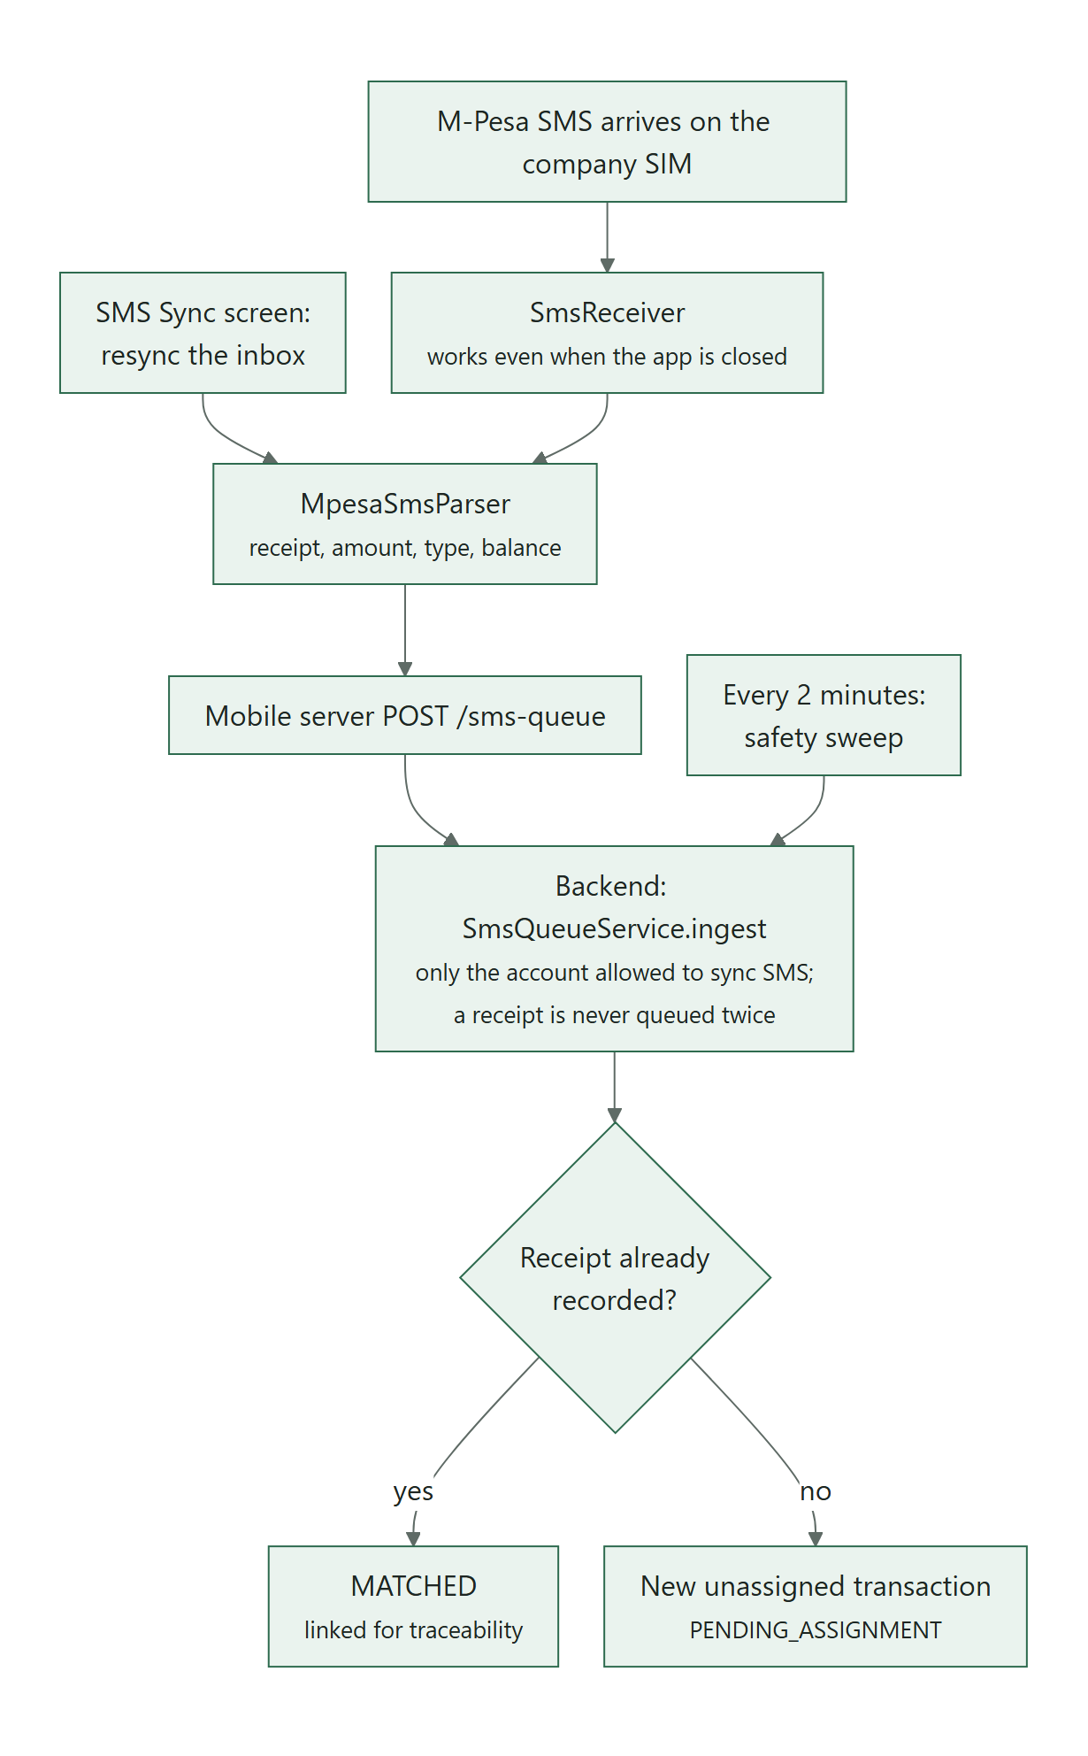
Figure 6: From an M-Pesa SMS on the company SIM to an unassigned transaction

5.12 Help page questions (FAQs)
Item | Details
Files | FaqController, FaqService, dto/FaqRequest
Tables | FAQS (migration 032)
Used by | Website (Help page, read only); desktop app (FAQs)

- GET /api/faqs is open and returns the published questions in Sort_Order. Managing them (/api/faqs/manage, create, edit, delete, restore) is admin only, and each change is written to AUDIT_LOGS (target table FAQS).
- Checks: a topic (up to 40 characters), a question (up to 250), an answer (up to 4,000) and, if given, a link that is a page on the website ("/shipping" - never an outside address). An unpublished question stays in the desktop list but not on the website; deleting is a soft delete.

5.13 Bulk order pictures (showcase)
Item | Details
Files | ShowcaseController, ShowcaseService, dto/ShowcaseRequest, dto/ShowcaseOrderRequest
Tables | SHOWCASE_IMAGES (migration 034)
Used by | Website (Bulk Orders slideshow, read only); phone and desktop apps (Marketing)

"pictures that can be used to show case what bulk orders look like": example photos for the website's Bulk Orders page, kept apart from products. Added on 9 October 2026.
- GET /api/showcase is open and returns the pictures in order (Sort_Order, then id), each with its picture address and caption. Adding, changing a caption, reordering and removing need a Marketer, Admin or SuperAdmin, checked from the token (AdminGuard.requireShowcaseEditor); each change is written to AUDIT_LOGS (target table SHOWCASE_IMAGES).
- Checks: the picture must be a key in the showcase folder (showcase/<name>.jpg, small letters, digits and hyphens - never another folder or an outside address); a caption is tidied (spaces) and kept to 120 characters; 12 pictures at most (409). A reorder must list every picture shown now, or it is refused (409 "The pictures changed meanwhile - refresh and try again"), so a stale screen cannot drop one. Removing is a soft delete (Deleted_By, Deleted_At).
- The picture files are written by the phone app server (/uploads/showcase) or the admin server (/showcase/upload) into media/showcase; the backend only stores the key.

5.14 Ratings and reviews
Item | Details
Files | ReviewController, ReviewService
Tables | PRODUCT_REVIEWS, ORDER_ITEMS, LIGHT_DELIVERIES

A customer can rate a product only after it has been delivered to them, once per product, with an optional comment. A rating is private unless the customer ticks "public" and accepts the public-review agreement (its version is stored). Public ratings show the first name and last-name initial. Averages appear only once a product has enough ratings. Admins can hide a review.
Where to adjust: The agreement version CONSENT_VERSION in service/ReviewService.java must match the website's src/core/reviewConsent.js. Change both together when the agreement text changes.

5.15 Delivery areas, machines and vehicles
ShippingController/ShippingService manage DELIVERY_AREAS (city, pickup point name, description, GPS coordinates, active flag). Customers see only active areas; staff see all. MachineController and VehicleController keep the machine and vehicle registries picked on expense forms; only the desktop app adds or edits them. A vehicle identifier already used by an expense cannot be changed.

5.16 Insights, AI and data browser
- InsightsController - expense breakdown per trip and category, highest first.
- AiChatController, AiChatService - the assistant for the website and the mobile app (see DWS-BE-04).
- AdminController, AdminDataService - raw table browser for the desktop app. The table name is checked against the names MySQL itself reports before any query runs. Values of columns whose name contains password, secret, token or public_key (today USERS.Password, USER_DEVICES.Public_Key, USER_COMPUTERS.Public_Key) are sent as "(hidden)".
- HealthController - GET /api/health reports the service and database status.

6 Scheduled jobs
Job | Schedule | What it does
SmsQueueService.reconcileAll | first after 30 s, then every 2 minutes | Matches queued M-Pesa SMS messages to transactions.
DescriptionFormatter.sweep | first after 45 s, then every 5 minutes | Creates or refreshes the AI-arranged copy of long product descriptions.
PhoneVerificationService.deleteOldRows | 03:20 every night | Deletes phone verification rows older than 30 days.
Table 3: Scheduled jobs (enabled by @EnableScheduling)

7 External services and network resilience
- M-Pesa Daraja through MpesaClient: HTTP/1.1, 4-second connect and 45-second read time-outs, access token cached for 50 minutes.
- Groq (chat) through GroqClient and Anthropic (scan, optional chat) through AnthropicClient. Both are skipped cleanly when no key is set.
- Google keys for sign-in through GoogleIdTokens.
- Africa's Talking (SMS codes for phone numbers) through SmsSender: 4-second connect and 5-second read time-outs; when it cannot send, codes pause for 10 minutes (see Accounts, sign-in and users).
- This network sometimes resolves a service name to a dead address. DNS caching is switched off and util/FlakyNetworkRetry retries up to 5 times. Reads may be retried after any I/O error; a payment request is retried only when nothing could have been sent (a connection failure), so money is never sent twice.

8 Error answers
Since 18 October 2026 an error answer never carries a stack trace, an exception name or binding details (server.error.* in application.properties - the development tools would otherwise switch traces on). The message stays: a reason written for people (ResponseStatusException, such as "Not enough stock ...") is passed on by the servers in front, which replace any 500 with a calm sentence and log the real one.

9 Configuration
All settings are in backend/src/main/resources/application.properties. Almost every value can be overridden by the environment variable shown, which is how secrets are supplied at start-up (the launch scripts export them). Values marked secret must never be written into documents, chat messages or source control.
Property | Environment variable | Default as shipped | Purpose
server.port | - | 8080 | Port the backend listens on.
server.address | - | 0.0.0.0 | Listen on all addresses (needed for WSL to Windows forwarding).
spring.datasource.url | - | jdbc:mysql://localhost:3309/dateroem?... | Database location (host, port 3309, database name).
spring.datasource.username | - | dateroem_backend | Database account the backend uses.
spring.datasource.password | DATEROEM_DB_PASSWORD | none - must be set (secret) | Database password.
app.media.base-url | MEDIA_BASE_URL | http://127.0.0.1:8000/media/ | Prefix that turns a stored image key into a full URL. Point at a CDN in production.
app.auth.jwt-secret | AUTH_JWT_SECRET | a development-only value (secret) | Key that signs sign-in tokens (at least 32 characters). Must be replaced for production.
app.auth.jwt-expiry-hours | AUTH_JWT_EXPIRY_HOURS | 720 (30 days) | How long a sign-in lasts.
app.auth.desktop-jwt-expiry-hours | AUTH_DESKTOP_JWT_EXPIRY_HOURS | 12 | How long a desktop-app sign-in lasts (approved computers only).
app.auth.tokens-valid-from | AUTH_TOKENS_VALID_FROM | 2026-10-18T08:30:00Z | Sign-in tokens issued before this moment are refused (set on 18 October 2026, when the clean-up renumbered the accounts). Move it forward to sign everybody out once.
server.error.include-stacktrace, include-exception, include-binding-errors, include-message | - | never, false, never, always | What an error answer may carry: never a stack trace or exception name; the message stays (the servers in front pass on only the ones written for people).
app.google.client-id | GOOGLE_CLIENT_ID | the Dateroem web client id | Google OAuth Web client ID for "Continue with Google" (Google Cloud project "Dateroem" under the business Gmail). Not a secret. Empty turns Google sign-in off.
app.google.jwks-uri | GOOGLE_JWKS_URI | https://www.googleapis.com/oauth2/v3/certs | Where Google's public signing keys are fetched.
app.ai.chat-provider | AI_CHAT_PROVIDER | groq | Which AI answers chat: groq or anthropic.
app.groq.api-key | GROQ_API_KEY | none (secret) | Groq API key (console.groq.com).
app.groq.chat-model | GROQ_CHAT_MODEL | openai/gpt-oss-120b | Main Groq chat model.
app.groq.fallback-chat-models | GROQ_FALLBACK_CHAT_MODELS | openai/gpt-oss-20b, qwen/qwen3.8-27b | Tried in order when the main model is at its per-minute limit.
app.anthropic.api-key | ANTHROPIC_API_KEY | none (secret) | Anthropic (Claude) API key - handwriting scan, optional chat.
app.anthropic.model | ANTHROPIC_MODEL | claude-haiku-4-5-20251001 | Model used for the handwriting scan.
app.anthropic.chat-model | ANTHROPIC_CHAT_MODEL | claude-sonnet-5 | Model used for chat when the provider is anthropic.
app.descriptions.ai-tidy-up | DESCRIPTION_AI_TIDY_UP | true | Let the AI arrange long product descriptions for the website.
app.mpesa.base-url | MPESA_BASE_URL | https://api.safaricom.co.ke (live since 16 October 2026) | Daraja host. The sandbox is https://sandbox.safaricom.co.ke.
app.mpesa.consumer-key | MPESA_CONSUMER_KEY | the live app's, in application.properties (secret) | Daraja app consumer key. Not exported by any start script: an export would override the file.
app.mpesa.consumer-secret | MPESA_CONSUMER_SECRET | the live app's, in application.properties (secret) | Daraja app consumer secret. Not exported by any start script.
app.mpesa.shortcode | MPESA_SHORTCODE | 1334200 (the store) | Paybill number, or for a till the store (head office) number the passkey belongs to.
app.mpesa.transaction-type | MPESA_TRANSACTION_TYPE | CustomerBuyGoodsOnline (till) | Paybill (CustomerPayBillOnline) or till (CustomerBuyGoodsOnline). Since 8 October 2026.
app.mpesa.party-b | MPESA_PARTY_B | 1804074 (the till) | Till only: the till number customers pay into. Since 8 October 2026.
app.mpesa.passkey | MPESA_PASSKEY | the live passkey Safaricom sent for the store (secret) | Lipa na M-Pesa Online passkey. Production passkey comes from Safaricom.
app.mpesa.callback-url | MPESA_CALLBACK_URL | https://<tunnel address>/api/dateroem-payments/stk | Public HTTPS address Safaricom posts STK results to. Production: https://<domain>/api/dateroem-payments/stk (DWS-CFG-03).
app.mpesa.b2c-initiator-name | MPESA_B2C_INITIATOR_NAME | still a sandbox value (secret) | B2C (Send Money) initiator user name. Send Money is not live: a till cannot pay out.
app.mpesa.b2c-initiator-password | MPESA_B2C_INITIATOR_PASSWORD | Safaricom sandbox test password (secret) | B2C initiator password (encrypted with the certificate before sending).
app.mpesa.b2c-shortcode | MPESA_B2C_SHORTCODE | 1334200 (no B2C account yet) | B2C paying shortcode - needs a B2C (disbursement) shortcode from Safaricom.
app.mpesa.b2c-cert-path | MPESA_B2C_CERT_PATH | src/main/resources/mpesa/SandboxCertificate.cer (holds the production certificate since 16 October 2026; the name was kept) | Safaricom public certificate used to encrypt the initiator password (Send Money only).
app.mpesa.b2c-result-url | MPESA_B2C_RESULT_URL | https://<tunnel address>/api/dateroem-payments/b2c-result | Where Safaricom posts B2C results. Production: https://<domain>/api/dateroem-payments/b2c-result.
app.mpesa.b2c-queue-timeout-url | MPESA_B2C_QUEUE_TIMEOUT_URL | same as the result URL | Where Safaricom posts B2C time-outs.
app.sms.provider | SMS_PROVIDER | off in the code; africastalking on this computer since 17 October 2026 | SMS codes that confirm phone numbers: off, africastalking, or test (this computer only - codes written to sms-test-outbox.txt, never sent).
app.sms.username | SMS_USERNAME | empty in the code; the Dateroem app on this computer | The Africa's Talking app username ("sandbox" = their sandbox).
app.sms.api-key | SMS_API_KEY | empty (secret) | The Africa's Talking API key. Codes are asked for only when the username and key are both set.
app.sms.sender-id | SMS_SENDER_ID | empty in the code; AFRICASTKNG on this computer | The sender name the SMS comes from. The shared AFRICASTKNG reaches Airtel numbers only; Safaricom needs Dateroem's own sender name, approved by Africa's Talking.
app.sms.networks | SMS_NETWORKS | all in the code; airtel on this computer | Which networks' numbers get codes: airtel, safaricom, telkom (a list) or all. Other numbers are taken as typed.
app.sms.test-outbox | SMS_TEST_OUTBOX | sms-test-outbox.txt | Test mode only: the file codes are written to instead of being sent.
Table 4: Backend settings
Caution: The shipped file contains development or sandbox defaults for the JWT secret, the M-Pesa passkey and the B2C initiator. They are fine for testing only. For production, set real values through environment variables and remove the defaults from the file (see DWS-CFG-02).

10 Building and running
Normally the backend is started from the desktop app's Servers section or by /root/run_backend.sh, which exports the secrets and runs Maven. By hand, inside WSL:
cd /root/fathersProject/backend
export DATEROEM_DB_PASSWORD=... # plus the other secrets listed under Configuration
export MAVEN_OPTS=-Djava.net.preferIPv4Stack=true
mvn spring-boot:run
- First start compiles the project and can take several minutes; the desktop app allows up to 300 seconds.
- Check it is up: curl http://127.0.0.1:8080/api/health should report the database as connected.
- With DevTools, mvn -q compile in another terminal restarts the running service with the new code.
- Logs: wherever the launcher redirects output (/tmp/backend-r9.log for run_backend.sh) or the desktop Servers log.

11 Known limitations and future work
- Only desktop sign-ins have a wrong-password limit (in the admin server, held in memory); website and mobile sign-ins have none yet.
- Role limits for most staff screens are applied by the apps, not enforced in the backend.
- When a failed STK payment is detected by the status query (rather than the callback), the payment is marked FAILED but the order is not cancelled automatically and its stock is not returned. The callback path does both.
- Several dates are stored without a time (for example FINANCIAL_TRANSACTION.Created_At), so same-day ordering falls back to the id.
- There are no automated tests beyond the default Spring context test.

12 Development history
Date | Area | Change
2026-09-11 | Database | Business-rules database reviewed (keys, table order), tables created with auto-increment keys, per-trip calculation functions and the profit procedure added.
2026-09-11 | Architecture | Technology chosen: Kotlin mobile app, Java backend, Python servers for the website and the mobile app; backend, website server and mobile server scaffolded.
2026-09-13 | Payments | M-Pesa Send Money (B2C) in the sandbox, including Safaricom's encryption certificate.
2026-09-15 | Operations | C:\Scripts launcher and desktop shortcut for starting all servers.
2026-09-15 | AI | AI insights (unassigned transactions, top farmers, expense breakdown), handwriting scan of bulk production sheets, chat assistant in the mobile app with saved history, assistant on the website (Groq).
2026-09-19 | Payments | Send Money for expenses with automatic receipts (no typing), loan details and Pay Loan, transfer animation with a bold confirmation step.
2026-09-20 | AI | Role-based navigation guidance and chat history browsing; website answers improved.
2026-09-20 | Operations | All test data cleared except products and trees (backup kept in db_backups); tunnel paths for the app and APK downloads.
2026-09-20 | Payments | Drop and refund of orders not yet on a trip.
2026-09-23 | Operations | Connectivity fixes; 14-point manual-test fix list; only one phone may read company SMS.
2026-09-25 | AI | Answers grouped into consistent categories; replies in Kiswahili when asked in Kiswahili.
2026-10-03 | Security | One approved phone per account: each app install has its own key in the phone's secure hardware, an account's first phone is approved automatically and any other phone waits for an admin; the acting user on mobile requests is now taken from the verified sign-in.
2026-10-03 | AI | Website answers point to the Featured page and mention a promotion only while it is running and has products.
2026-10-05 | Security | Desktop app ready to work from any computer: it signs in only on approved computers (a key kept by Windows, in the TPM chip where there is one), the backend checks the sign-in on every desktop call and takes the acting user from it, desktop sign-ins last 12 hours, and 5 wrong passwords mean a 15-minute wait.
2026-10-05 | Security | One SuperAdmin (sadmin): only the SuperAdmin approves or blocks phones and computers, can change the SuperAdmin account, and hands the role over in one step; the other two former SuperAdmins became Admin with the same access as before.
2026-10-05 | Database | Migration 031: USER_COMPUTERS. The database browser shows password and key columns as (hidden).
2026-10-05 | Operations | The admin server serves product and campaign pictures itself (media/ addresses), so they load wherever the desktop app runs.
2026-10-07 | Security | Servers panel: anyone can start the servers (signed in or not), only the SuperAdmin can stop them, after a confirmation.
2026-10-08 | Operations | Website unreachable from phones after an internet drop: the Tunnel Router (Caddy) had not come back while ngrok and the other servers had; restarted.
2026-10-08 | Payments | Ready for Go Live by settings alone: paybill or till chosen with MPESA_TRANSACTION_TYPE and MPESA_PARTY_B (no code edit), and the M-Pesa callbacks also answer at /api/dateroem-payments, a production address without "mpesa" in it (Safaricom rejects such addresses).
2026-10-08 | Operations | Hosting planned: a 4 GB Ubuntu VPS in a Nairobi data centre and a .co.ke domain. Deployment kit in deploy/ (router with automatic HTTPS, start-on-boot services, settings templates, setup, release, install, daily backup and health-check scripts) and the Hosting and Deployment Guide.
2026-10-09 | Security | Security review before going public: a payment result counts only when Safaricom's own status query confirms it, never the message posted to the public callback address; order quantities must be whole numbers of 1 or more, and the same product twice is added together before the stock check; the phone app accepts staff accounts only; the servers' API description pages are off; payout amounts must be positive whole shillings up to KES 1,000,000; Send Money and loan payments go to the number on file (another number needs the SuperAdmin); a failed payment is cleaned up (order cancelled, stock returned) however the failure is seen.
2026-10-09 | Database | Migration 033: PRODUCTS.Is_Retired, Retired_At and Retired_By, for retiring a product.
2026-10-09 | Database | Migration 034: SHOWCASE_IMAGES, the example pictures of the website's Bulk Orders slideshow.
2026-10-16 | Payments | M-Pesa live: the Daraja app went live on the company till 1804074 (store 1334200) with the live keys and passkey.
2026-10-17 | Payments | First live STK payment (KES 5, receipt received, result delivered to /api/dateroem-payments/stk and checked with Safaricom). Fixed on the way: the Daraja address still pointed at the sandbox, the start scripts exported the old sandbox keys (which override application.properties), and the callbacks used a path with "mpesa" in it. Send Money is not live: a till cannot pay out.
2026-10-17 | Database | Migration 035: PRODUCT_PAYMENTS.Mpesa_Receipt - the M-Pesa receipt of a website payment in its own column (filled for earlier payments from their description).
2026-10-17 | Database | Migration 036: USERS.Phone_Verified_At and PHONE_VERIFICATIONS - phone numbers confirmed by an SMS code.
2026-10-18 | Operations | After a restart of the computer the servers were found stopped (website and payments offline); they can now be started in the background without the desktop app (/root/dateroem_start).
2026-10-18 | Database | Clean-up before going live: test orders, payments, deliveries, trips, loans and finance, farmers, machines, vehicles, chats and the SMS queue removed, disabled accounts deleted, and everything kept numbered from 1 - the SuperAdmin is user 1, the two admins 2 and 3, the one real customer 4; the real KES 5 order is order 1; products 1-7. Full backups and a record in db_backups.
2026-10-18 | Security | Sign-in tokens issued before the clean-up are refused (AUTH_TOKENS_VALID_FROM), so an old token can never name a renumbered account; everyone signs in once more.
2026-10-20 | Operations | The website server would not start after the internet dropped: the WSL network layer had frozen (npm stuck in netlink_dump). Restarting WSL and the servers fixed it.
Table 5: Backend-related milestones

13 Appendix A - Endpoint reference
All paths start with /api. "Caller identity" shows what the endpoint reads: a signed-in token, the acting user id header set by the mobile or admin server, or nothing (called by the Python servers on behalf of their clients). "Admin enforced" means the backend itself rejects non-admins.

13.1 Admin
Method | Path | Purpose | Caller identity
GET | /api/admin/tables | List every database table (desktop database browser). | Signed-in token, admin enforced
GET | /api/admin/tables/{tableName} | Raw rows of one table, with paging. | Signed-in token, admin enforced

13.2 AiChat
Method | Path | Purpose | Caller identity
GET | /api/ai/chat/history | The signed-in user's saved chat conversation. | Token and acting user
POST | /api/ai/chat | Ask the AI assistant (web or mobile channel). | Token and acting user
GET | /api/ai/chat/status | Whether the assistant can answer right now. | Called by the servers

13.3 Auth
Method | Path | Purpose | Caller identity
POST | /api/auth/register | Create a Customer account (website sign-up; username and email checked). | Called by the servers
POST | /api/auth/login | Sign in with a username or email and password; returns a JWT. From the desktop app: Admin or SuperAdmin only, on an approved computer, valid 12 hours. | Called by the servers
GET | /api/auth/providers | Which sign-in options are on (Google client id) and whether sign-up asks for an SMS code, and for which networks (phoneCode, phoneCodeFor). | Called by the servers
POST | /api/auth/google | Sign in or sign up with a Google ID token. | Called by the servers
GET | /api/auth/me | Who the current token belongs to, with the phone number and whether it still needs confirming by SMS code (phoneCodeRequired). | Signed-in token
PUT | /api/auth/me/theme | Save the signed-in account's colour theme (forest, dark or light). | Signed-in token
PUT | /api/auth/me/profile | The signed-in person's own name and email (the current password when the email changes). | Signed-in token
PUT | /api/auth/me/photo | The profile photo's media key (profiles/u<id>-<random>.jpg, saved by the website, phone or desktop server), or none. | Signed-in token
POST | /api/auth/me/password | Change the password (the current one first); answers a new token for this device - every other sign-in ends. | Signed-in token
POST | /api/auth/me/verify-password | Is this the account's password? (unlocking the desktop app after the idle lock; limits on wrong tries). | Signed-in token
POST | /api/auth/phone/send-code | Sign-up: send a 6-digit SMS code to a phone number (limits per number and overall); answers codeNeeded false, sending nothing, for a number that gets no code. | Called by the servers
POST | /api/auth/phone/verify | Sign-up: check the code; the right one returns a one-time phone proof that /register or /google carries. | Called by the servers
POST | /api/auth/me/phone/send-code | A signed-in customer: send a code to confirm their phone number (asked before the first order). | Signed-in token
POST | /api/auth/me/phone/verify | A signed-in customer: check the code; the confirmed number becomes the account's number. | Signed-in token

13.4 Computer
Method | Path | Purpose | Caller identity
GET | /api/auth/computer/challenge | One-time value the desktop app signs with its computer key before signing in. | Open (before sign-in)
GET | /api/computers | Every computer the desktop app has signed in on, waiting ones first (admin, desktop app only). | Signed-in token, admin enforced
POST | /api/computers/{computerId}/approve | Approve a waiting computer; replace=true swaps out the account's current one (SuperAdmin, desktop app only). | Signed-in token, SuperAdmin enforced
POST | /api/computers/{computerId}/revoke | Reject a waiting computer or block an approved one (SuperAdmin, desktop app only). | Signed-in token, SuperAdmin enforced

13.5 Delivery
Method | Path | Purpose | Caller identity
GET | /api/deliveries/light | Light deliveries, optionally for one trip. | Called by the servers
PATCH | /api/deliveries/light/{lightDeliveryId}/status | Change a light delivery's status. | Called by the servers
PATCH | /api/deliveries/light/{lightDeliveryId}/deliver | Mark delivered with "received by" and signature. | Called by the servers
GET | /api/deliveries/light/unassigned | Orders not yet on any trip. | Called by the servers
POST | /api/deliveries/light | Open a new light delivery on a trip. | Acting user id
GET | /api/deliveries/light/pending-groups | Pending orders grouped per customer and area. | Called by the servers
POST | /api/deliveries/light/assign-batch | Put a group of orders on one delivery. | Acting user id
POST | /api/deliveries/light/settle | Settle a delivery: delivered vs back to the pool. | Acting user id
PATCH | /api/deliveries/light/{lightDeliveryId}/assign | Assign one order to a trip, vehicle and date. | Acting user id
PATCH | /api/deliveries/light/{lightDeliveryId}/share-driver | Share driver on a delivery and the orders under it - whether customers see the driver's first name and the number plate. | Acting user id
GET | /api/deliveries/bulk | Bulk (heavy) deliveries, optionally for one trip. | Called by the servers
GET | /api/deliveries/bulk/{bulkDeliveryId} | One bulk delivery. | Called by the servers
GET | /api/deliveries/bulk/production/{descriptionId}/photo | Photo of a production description line. | Called by the servers
GET | /api/deliveries/bulk/{bulkDeliveryId}/production | Production description lines of a bulk delivery. | Called by the servers
POST | /api/deliveries/bulk/{bulkDeliveryId}/production | Add a production description line. | Called by the servers
PATCH | /api/deliveries/bulk/production/{descriptionId} | Correct a production description line. | Called by the servers
DELETE | /api/deliveries/bulk/production/{descriptionId} | Remove a production description line. | Acting user id
POST | /api/deliveries/bulk/{bulkDeliveryId}/production/scan | AI-read a photographed handwritten sheet. | Called by the servers
POST | /api/deliveries/bulk | Open a heavy order (ORDERS + BULK_DELIVERY pair). | Acting user id
DELETE | /api/deliveries/bulk/{bulkDeliveryId} | Delete a heavy order that fell through. | Acting user id
PATCH | /api/deliveries/bulk/{bulkDeliveryId}/finalize | Record payment and mark a bulk delivery delivered. | Acting user id

13.6 Device
Method | Path | Purpose | Caller identity
GET | /api/auth/device/challenge | One-time value a phone signs before signing in. | Open (before sign-in)
GET | /api/devices | Every phone that has signed in, waiting ones first (admin). | Signed-in token, admin enforced
POST | /api/devices/{deviceId}/approve | Approve a waiting phone; replace=true swaps out the current one (SuperAdmin). | Signed-in token, SuperAdmin enforced
POST | /api/devices/{deviceId}/revoke | Reject a waiting phone or block an approved one (SuperAdmin). | Signed-in token, SuperAdmin enforced

13.7 Expense
Method | Path | Purpose | Caller identity
GET | /api/trips/{tripId}/expenses | Per-category expense totals for a trip. | Called by the servers
GET | /api/trips/{tripId}/expenses/{category} | Entries of one category (all, assigned or pending). | Called by the servers
POST | /api/trips/{tripId}/expenses/{category} | Create an expense entry (holder awaiting payment). | Acting user id
DELETE | /api/trips/{tripId}/expenses/{category}/{rowId} | Delete an unpaid entry (own, or any for admins). | Acting user id, admin enforced

13.8 Faq
Method | Path | Purpose | Caller identity
GET | /api/faqs | The Help page's published questions, in display order (open). | Called by the servers
GET | /api/faqs/manage | Every question, hidden ones too, or only the deleted ones (admin, desktop app). | Signed-in token, admin enforced
POST | /api/faqs | Add a question (admin). | Signed-in token, admin enforced
PATCH | /api/faqs/{faqId} | Edit a question, including hiding it from the website (admin). | Signed-in token, admin enforced
DELETE | /api/faqs/{faqId} | Soft-delete a question (admin). | Signed-in token, admin enforced
POST | /api/faqs/{faqId}/restore | Bring a deleted question back (admin). | Signed-in token, admin enforced

13.9 Farmer
Method | Path | Purpose | Caller identity
GET | /api/farmers | All farmers. | Called by the servers
GET | /api/farmers/{farmerId} | One farmer. | Called by the servers
GET | /api/farmers/insights/top-suppliers | Farmers ranked by trees supplied. | Called by the servers
POST | /api/farmers | Register a farmer. | Called by the servers
PATCH | /api/farmers/{farmerId} | Edit a farmer. | Called by the servers

13.10 FarmerPayment
Method | Path | Purpose | Caller identity
POST | /api/farmer-payments | Record a payment to a farmer. | Acting user id
GET | /api/farmer-payments | Payments made to one farmer. | Called by the servers

13.11 Health
Method | Path | Purpose | Caller identity
GET | /api/health | Service and database health. | Called by the servers

13.12 Insights
Method | Path | Purpose | Caller identity
GET | /api/insights/expenses/breakdown | Expense totals per trip and category, highest first. | Called by the servers
GET | /api/insights/overview | The business at a glance for the phone's Home: users by role, products, campaigns, trips, and the orders waiting - with how many are close to or past the promised date (Admins and the SuperAdmin). | Signed-in token, admin enforced

13.13 LoanFinance
Method | Path | Purpose | Caller identity
GET | /api/trips/{tripId}/finance/loans | Loans of a trip with paid and remaining amounts. | Called by the servers
POST | /api/trips/{tripId}/finance/loans | Add a loan (admin). | Acting user id, admin enforced
PATCH | /api/loans/{loanId} | Edit a loan or change its status (admin). | Acting user id, admin enforced
GET | /api/trips/{tripId}/finance/capital | Capital entries of a trip. | Called by the servers
POST | /api/trips/{tripId}/finance/capital | Add capital (admin). | Acting user id, admin enforced
PATCH | /api/finance/capital/{capitalId} | Edit capital (admin). | Acting user id, admin enforced
GET | /api/loans/{loanId}/repayments | Repayments of a loan (paid or pending). | Called by the servers
POST | /api/loans/{loanId}/repayments | Record a manual repayment. | Called by the servers
POST | /api/loans/{loanId}/repayments/pay | Pay a loan through M-Pesa Send Money (admin). | Acting user id, admin enforced

13.14 Machine
Method | Path | Purpose | Caller identity
GET | /api/machines | All machines. | Called by the servers
GET | /api/machines/{machineId} | One machine. | Called by the servers
POST | /api/machines | Add a machine (desktop). | Called by the servers
PATCH | /api/machines/{machineId} | Edit a machine (desktop). | Called by the servers

13.15 Marketing
Method | Path | Purpose | Caller identity
GET | /api/marketing/campaigns | Campaigns (newest first). | Called by the servers
GET | /api/marketing/campaigns/deleted | Deleted campaigns (bin). | Called by the servers
GET | /api/marketing/campaigns/{campaignId} | One campaign. | Called by the servers
POST | /api/marketing/campaigns | Create a campaign. | Acting user id
PATCH | /api/marketing/campaigns/{campaignId} | Edit a campaign. | Acting user id
DELETE | /api/marketing/campaigns/{campaignId} | Move a campaign to the bin. | Acting user id
POST | /api/marketing/campaigns/{campaignId}/restore | Restore a campaign from the bin. | Acting user id
POST | /api/marketing/campaigns/{campaignId}/products/{productId} | Link a product to a campaign. | Called by the servers
GET | /api/marketing/campaigns/{campaignId}/products | Products linked to a campaign. | Called by the servers
PUT | /api/marketing/campaigns/{campaignId}/products | Replace the products a campaign promotes (audit line). | Acting user id
POST | /api/marketing/campaigns/{campaignId}/audience/{userId} | Add a user to a campaign audience. | Called by the servers

13.16 MpesaCallback
Method | Path | Purpose | Caller identity
POST | /api/dateroem-mpesa-callback/stk | Safaricom STK push result (public, through Caddy). Also at /api/dateroem-payments/stk, the production address. | Safaricom (public)
POST | /api/dateroem-mpesa-callback/b2c-result | Safaricom B2C result or time-out (public, through Caddy). Also at /api/dateroem-payments/b2c-result. | Safaricom (public)

13.17 Order
Method | Path | Purpose | Caller identity
POST | /api/orders | Place a website order and send the STK push. | Signed-in token
GET | /api/orders/mine | The signed-in customer's orders. | Signed-in token
GET | /api/orders/track | Track my order without signing in: the ticket and the last 3 digits of the account's phone (website orders only; five wrong tries lock the ticket for 30 minutes). | Open (ticket and phone digits)
GET | /api/orders/{orderId} | One order (owner only); settles a pending payment. | Signed-in token
POST | /api/orders/{orderId}/drop | Drop an order and work out the refund (admin). | Signed-in token, admin enforced
GET | /api/orders/refunds/pending | Dropped orders still owed a refund (admin). | Signed-in token, admin enforced
GET | /api/orders/payments | Website payments, newest first, with their M-Pesa receipts (admin). | Signed-in token, admin enforced

13.18 Product
Method | Path | Purpose | Caller identity
GET | /api/products | Products (newest first); retired ones only with includeRetired=true (the admin apps). | Called by the servers
GET | /api/products/popular | Most ordered products. | Called by the servers
GET | /api/products/deleted | Deleted products (bin). | Called by the servers
GET | /api/products/{productId} | One product; a retired one only with includeRetired=true (404 for the shop). | Called by the servers
POST | /api/products | Create a product. | Acting user id
PATCH | /api/products/{productId} | Edit a product. | Acting user id
DELETE | /api/products/{productId} | Move a product to the bin. | Acting user id
POST | /api/products/{productId}/restore | Restore a product from the bin. | Acting user id
GET | /api/products/depleted | Products that have run out and are not retired (admins' "needs attention" list). | Called by the servers
POST | /api/products/{productId}/retire | Retire a product: hidden from the shop and not orderable; stock and orders kept. | Acting user id, admin enforced
POST | /api/products/{productId}/unretire | Bring a retired product back into the shop. | Acting user id, admin enforced

13.19 RemainderTree
Method | Path | Purpose | Caller identity
GET | /api/remainder-trees | Remainder trees (optionally from one trip). | Called by the servers
GET | /api/remainder-trees/{remainderTreesId} | One remainder record. | Called by the servers
POST | /api/remainder-trees | Record trees left over at trip end. | Called by the servers
PATCH | /api/remainder-trees/{remainderTreesId} | Edit a remainder record. | Called by the servers

13.20 Review
Method | Path | Purpose | Caller identity
GET | /api/reviews/summary | Average rating and count per product. | Called by the servers
GET | /api/reviews/product/{productId} | Public reviews of one product. | Called by the servers
GET | /api/reviews/mine | Products this customer can rate, and their ratings. | Signed-in token
PUT | /api/reviews/product/{productId} | Create or edit this customer's rating. | Signed-in token
DELETE | /api/reviews/product/{productId} | Remove this customer's rating. | Signed-in token
GET | /api/reviews/admin | All reviews with authors (admin moderation). | Signed-in token, admin enforced
POST | /api/reviews/admin/{reviewId}/hidden | Hide or show a review (admin). | Signed-in token, admin enforced

13.21 Role
Method | Path | Purpose | Caller identity
GET | /api/roles | All roles. | Called by the servers

13.22 Shipping
Method | Path | Purpose | Caller identity
GET | /api/shipping/areas | Delivery areas (active only, or all for staff). | Called by the servers
GET | /api/shipping/areas/{areaId} | One delivery area. | Called by the servers
POST | /api/shipping/areas | Add a delivery area. | Called by the servers
PATCH | /api/shipping/areas/{areaId} | Edit or switch off a delivery area. | Called by the servers

13.23 Showcase
Method | Path | Purpose | Caller identity
GET | /api/showcase | The Bulk Orders slideshow pictures, in order (public). | Called by the servers
POST | /api/showcase | Add a picture (an uploaded showcase/ key, optional caption); 12 at most. | Signed-in token, Marketer or admin enforced
PATCH | /api/showcase/{showcaseId} | Change or clear a picture's caption. | Signed-in token, Marketer or admin enforced
PUT | /api/showcase/order | Put the pictures in a new order (every picture's id, or 409). | Signed-in token, Marketer or admin enforced
DELETE | /api/showcase/{showcaseId} | Take a picture out of the slideshow (kept, marked removed). | Signed-in token, Marketer or admin enforced

13.24 SmsQueue
Method | Path | Purpose | Caller identity
POST | /api/sms-queue | Company phone posts an M-Pesa SMS. | Signed-in token
GET | /api/sms-queue | Queued SMS messages by status. | Called by the servers
POST | /api/sms-queue/reconcile | Run the SMS matching sweep now. | Called by the servers

13.25 Transaction
Method | Path | Purpose | Caller identity
POST | /api/transactions/claim | Claim a batch of unassigned payments. | Acting user id
GET | /api/transactions/claimed | Payments claimed by the acting user. | Acting user id
GET | /api/transactions/unassigned | All unassigned payments. | Called by the servers
POST | /api/transactions/{financialTransactionId}/release | Give a claimed payment back to the pool. | Called by the servers
GET | /api/transactions/{financialTransactionId}/candidates | Suggested entries a payment may belong to. | Called by the servers
POST | /api/transactions/{financialTransactionId}/assign | Assign a payment to an entry; recalculates profit. | Acting user id
POST | /api/transactions/stk-push | Send an STK push to a customer's phone. | Acting user id
POST | /api/transactions/{financialTransactionId}/stk-push/confirm | Manually confirm an STK payment with its receipt. | Acting user id
POST | /api/transactions/send-money | Pay an entry out with M-Pesa B2C (admin). | Acting user id, admin enforced
GET | /api/transactions/{financialTransactionId}/status | Status of an outgoing payment. | Called by the servers
GET | /api/transactions/send-money/recipient | Recipient name, phone and amount for an entry. | Called by the servers
POST | /api/transactions/{financialTransactionId}/send-money/confirm | Manually confirm a payout receipt (admin). | Acting user id, admin enforced

13.26 Tree
Method | Path | Purpose | Caller identity
GET | /api/trees | Tree registrations (optionally one trip). | Called by the servers
GET | /api/trees/deleted | Deleted tree registrations (bin). | Called by the servers
GET | /api/trees/{treesId} | One tree registration. | Called by the servers
POST | /api/trees | Register trees. | Called by the servers
PATCH | /api/trees/{treesId} | Edit a registration. | Called by the servers
DELETE | /api/trees/{treesId} | Move a registration to the bin. | Acting user id
POST | /api/trees/{treesId}/restore | Restore a registration. | Acting user id

13.27 Trip
Method | Path | Purpose | Caller identity
GET | /api/trips | Trips (newest first). | Called by the servers
GET | /api/trips/open | The trip that is still open, if any. | Called by the servers
GET | /api/trips/{tripId}/finalization | What still blocks finalizing a trip. | Called by the servers
POST | /api/trips/{tripId}/finalize | Finalize a trip. | Acting user id
GET | /api/trips/{tripId} | One trip. | Called by the servers
POST | /api/trips | Create a trip (refused while another is open). | Called by the servers
PATCH | /api/trips/{tripId} | Edit trip details. | Called by the servers
DELETE | /api/trips/{tripId} | Delete a trip; its orders return to the pool. | Acting user id
GET | /api/trips/{tripId}/summary | Trip totals and profit. | Called by the servers
POST | /api/trips/{tripId}/total-payment/recalculate | Recalculate the trip's total payment. | Called by the servers
PUT | /api/trips/{tripId}/cash-split | Save the hard and soft cash split. | Called by the servers

13.28 User
Method | Path | Purpose | Caller identity
GET | /api/users/lookup-by-phone | Find an account name by phone number. | Signed-in token
GET | /api/users/picker | Id and name list for pickers. | Signed-in token
GET | /api/users | All accounts (admin). | Signed-in token, admin enforced
GET | /api/users/{userId} | One account (admin). | Signed-in token, admin enforced
POST | /api/users | Create a staff account with any role (admin). | Signed-in token, admin enforced
PATCH | /api/users/{userId} | Edit an account (admin); the SuperAdmin may also correct its username. | Signed-in token, admin enforced
PATCH | /api/users/{userId}/status | Enable or disable an account (admin). | Signed-in token, admin enforced
POST | /api/users/{userId}/reset-password | Reset an account's password to a temporary one, shown once to the admin, which must be changed at the next sign-in (only the SuperAdmin resets an Admin). | Signed-in token, admin enforced

13.29 Vehicle
Method | Path | Purpose | Caller identity
GET | /api/vehicles | All vehicles. | Called by the servers
GET | /api/vehicles/{vehicleId} | One vehicle. | Called by the servers
POST | /api/vehicles | Add a vehicle (desktop). | Called by the servers
PATCH | /api/vehicles/{vehicleId} | Edit a vehicle (desktop). | Called by the servers

13.30 Settings
Method | Path | Purpose | Caller identity
GET | /api/settings/idle-lock | The idle lock's minutes (the phone and desktop apps lock after that long untouched). | Signed-in token
PUT | /api/settings/idle-lock | Set the idle lock's minutes, 5 to 120 (SuperAdmin). | Signed-in token, SuperAdmin enforced
GET | /api/settings/company | The company card on the phone's Home (name, motto, code) - the same on every phone. | Signed-in token
PUT | /api/settings/company | Change the company card (SuperAdmin). | Signed-in token, SuperAdmin enforced

13.31 Worker
Method | Path | Purpose | Caller identity
GET | /api/workers/me | The signed-in staff member's own worker details: every field asked for with their value, each document type with when its photo was sent (never the photo), and where it stands. | Signed-in token
PUT | /api/workers/me | Save the staff member's own details (numbers checked by kind; ID-type numbers stored encrypted). Sent for checking once every required item is there; a change after Verified sends it back for checking. | Signed-in token
POST | /api/workers/me/documents/{typeKey} | A photo of one of the staff member's documents (a JPEG of at most 3 MB, made by the phone server), stored encrypted; replaces the earlier photo of that document. | Signed-in token
GET | /api/workers | Every staff account and where its worker details stand - counts only, no numbers or photos (admins). | Signed-in token, admin enforced
GET | /api/workers/definitions | The fields and document types staff are asked for, including those no longer asked (admins). | Signed-in token, admin enforced
POST | /api/workers/fields | Ask staff for a new detail: name, kind (text, number, date or phone), hint, encrypted or not, required or not (SuperAdmin). | Signed-in token, SuperAdmin enforced
PATCH | /api/workers/fields/{fieldKey} | Stop or start asking for a detail; what was given is kept (SuperAdmin). | Signed-in token, SuperAdmin enforced
POST | /api/workers/doc-types | Ask staff for a new document photo (SuperAdmin). | Signed-in token, SuperAdmin enforced
PATCH | /api/workers/doc-types/{typeKey} | Stop or start asking for a document photo (SuperAdmin). | Signed-in token, SuperAdmin enforced
GET | /api/workers/{userId} | One staff member's details, decrypted, and their document list (SuperAdmin; written to the audit log). | Signed-in token, SuperAdmin enforced
GET | /api/workers/{userId}/documents/{documentId} | One document photo, decrypted, as base64 (SuperAdmin; written to the audit log). | Signed-in token, SuperAdmin enforced
POST | /api/workers/{userId}/verify | Mark the details Verified, or Needs changes with a note the staff member sees (SuperAdmin). | Signed-in token, SuperAdmin enforced
DELETE | /api/workers/{userId}/documents/{documentId} | Delete one document photo (SuperAdmin). | Signed-in token, SuperAdmin enforced
DELETE | /api/workers/{userId} | Delete every detail and photo kept for a staff member (SuperAdmin). | Signed-in token, SuperAdmin enforced

